

MS-WORD

INTRODUCTION TO COMPUTING



fall-2017

MOHAMMAD ALI JINNAH UNIVERSITY

Table of Contents

LAB:01 2

MS-WORD 2016 2

Introduction 2

Working with the Word environment 5

The Ribbon 5

The Quick Access Toolbar 8

The Ruler 9

Backstage view 10

Document views and zooming 11

Task 14

Introduction 15

LAB:02 45

Using Find and Replace 45

Line and Paragraph Spacing 52

Lists 60

Hyperlinks 61

Introduction 61

Page Layout 66

Page size 68

Page margins 71

Printing Documents 76

Breaks 76

Section breaks 79

Other types of breaks 85

Headers and Footers 90

Introduction 90

Editing headers and footers 95

Formatting Pictures 100

Making image adjustments 104

Compressing pictures 108

Text Boxes 109

Tables 113

Charts 117

Introduction 117

Inserting charts 117

Track Changes and Comments 121

Reviewing changes 122

Inspecting and Protecting Documents 123

Document Inspector 123

Protecting your document 126

## **LAB:01**

## **MS-WORD 2016**

**Introduction**

Microsoft Word 2016 is a **word processing** application that allows you to create a variety of **documents**, including letters, resumes, and more. In this lesson, you'll learn how to navigate the Word interface and become familiar with some of its most important features, such as the **Ribbon**, **Quick Access Toolbar**, and **Backstage view**.

**Getting to know Word 2016**

**Word 2016** is similar to Word 2013 and Word 2010. If you've previously used either version, then Word 2016 should feel familiar. But if you are new to Word or have more experience with older versions, you should first take some time to become familiar with the **Word 2016 interface**.

**The Word interface**

When you open Word for the first time, the**Start Screen** will appear. From here, you'll be able to create a **new document**, choose a **template**, and access your **recently edited documents**. From the**Start Screen**, locate and select **Blank document** to access the Word interface.

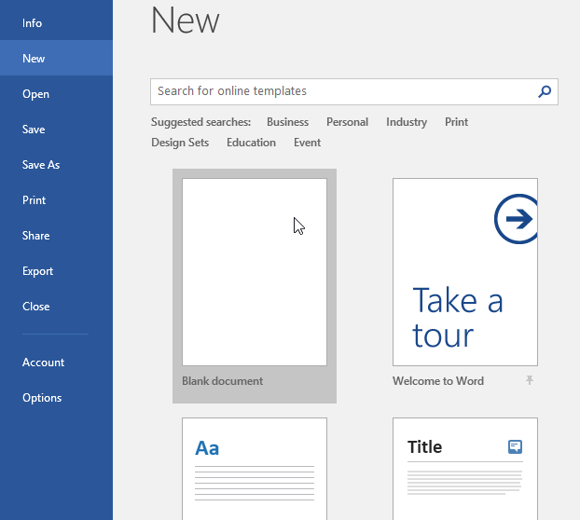

Click the buttons in the interactive below to learn more about the Word interface:

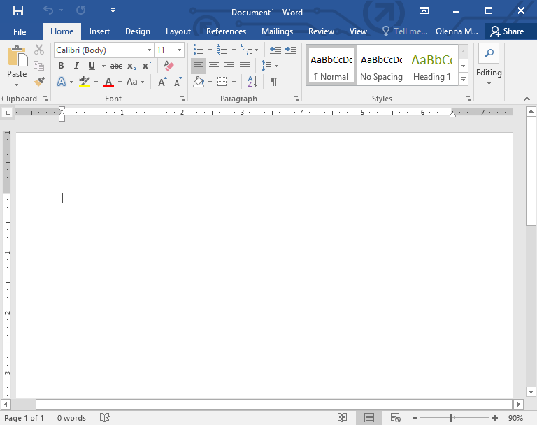

**Working with the Word environment**

Like other recent versions, Word 2016 continues to use features like the **Ribbon** and the **Quick Access Toolbar**—where you will find commands to perform common tasks in Word—as well as**Backstage view**.

**The Ribbon**

Word uses a **tabbed Ribbon system** instead of traditional menus. The **Ribbon** contains **multiple tabs**, which you can find near the top of the Word window.

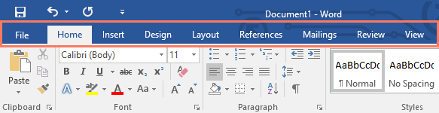

Each tab contains several **groups of related commands**. For example, the Font group on the Home tab contains commands for formatting text in your document.

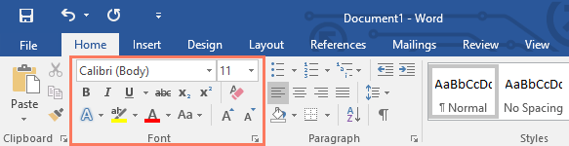

Some groups also have a **small arrow** in the bottom-right corner that you can click for even more options.

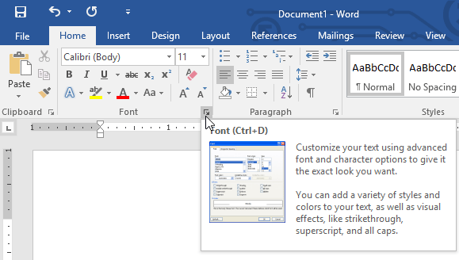

Showing and hiding the Ribbon

If you you find that the Ribbon takes up too much screen space, you can hide it. To do this, click the **Ribbon Display Options** arrow in the upper-right corner of the Ribbon, then select the desiredoption from the drop-down menu:

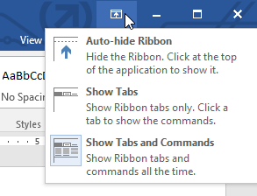

* **Auto-hide Ribbon**: Auto-hide displays your document in full-screen mode and completely hides the Ribbon from view. To show the Ribbon, click the **Expand Ribbon** command at the top of screen.
* **Show Tabs**: This option hides all command groups when they're not in use, but tabs will remain visible. To show the Ribbon, simply click a tab.
* **Show Tabs and Commands:** This option maximizes the Ribbon. All of the tabs and commands will be visible. This option is selected by default when you open Word for the first time.

To learn how to add **custom tabs** and **commands** to the Ribbon, review our Extra on [**Customizing the Ribbon**](http://www.gcflearnfree.org/word2013/customizing-the-ribbon/1/).

Using the Tell me feature

If you're having trouble finding command you want, the**Tell Me**feature can help. It works just like a regular search bar: Type what you're looking for, and a list of options will appear. You can then use the command directly from the menu without having to find it on the Ribbon.

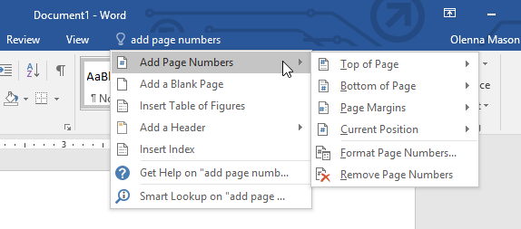

**The Quick Access Toolbar**

Located just above the Ribbon, the **Quick Access Toolbar** lets you access common commands no matter which tab is selected. By default, it shows the **Save**, **Undo**, and **Redo** commands, but you can add other commands depending on your needs.

**To add commands to the Quick Access Toolbar:**

1. Click the **drop-down arrow** to the right of the **Quick Access Toolbar**.

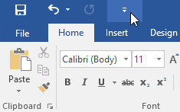

1. Select the**command** you want to add from the menu.

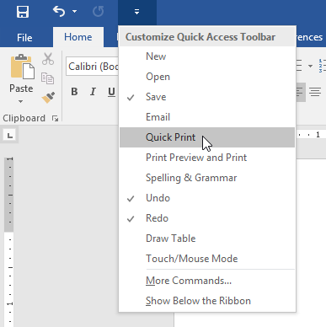

1. The command will be **added** to the Quick Access Toolbar.

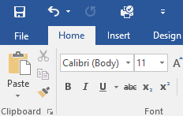

**The Ruler**

The**Ruler** is located at the top and to the left of your document. It makes it easier to **adjust** your document with precision. If you want, you can hide the Ruler to create more screen space.

**To show or hide the Ruler:**

1. Click the **View**tab.

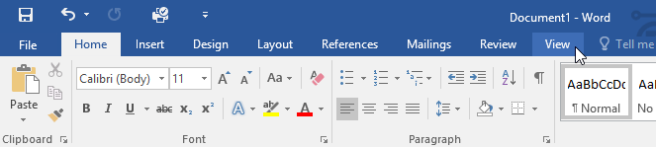

1. Click the checkbox next to **Ruler** to **show** or **hide** the Ruler.

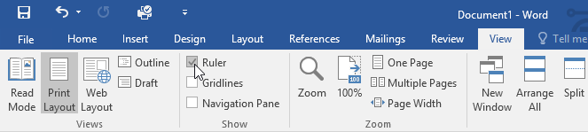

Backstage view

**Backstage view** gives you various options for saving, opening a file, printing, and sharing your document. To access Backstage view, click the **File** tab on the **Ribbon**.

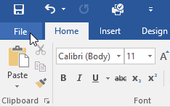

Click the buttons in the interactive below to learn more about using backstage view.

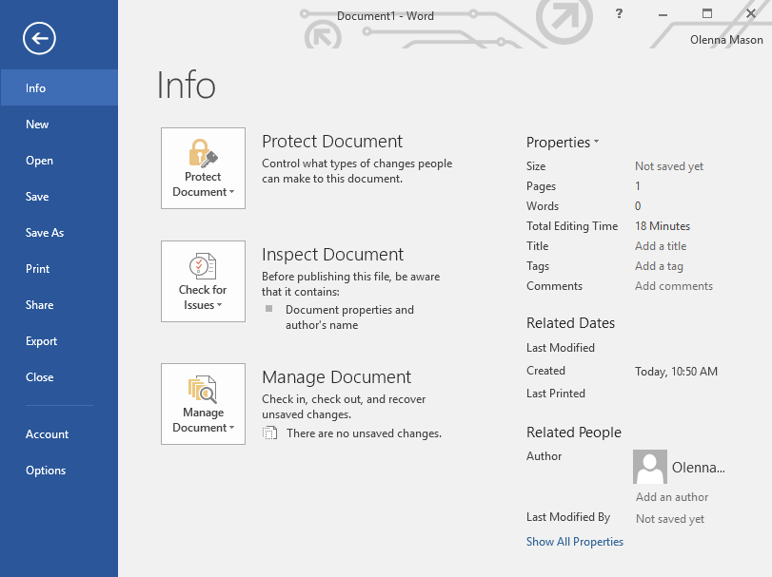

Document views and zooming

Word has a variety of viewing options that change how your document is displayed. You can choose to view your document in **Read Mode**, **Print Layout**, or **Web Layout**. These views can be useful for various tasks, especially if you're planning to **print** the document. You can also **zoom in and out** to make your document easier to read.

Switching document views

Switching between different document views is easy. Just locate and select the desired **document view command** in the bottom-right corner of the Word window.

* **Read Mode**: This view opens the document to a full screen. This view is great for reading large amounts of text or simply reviewing your work.

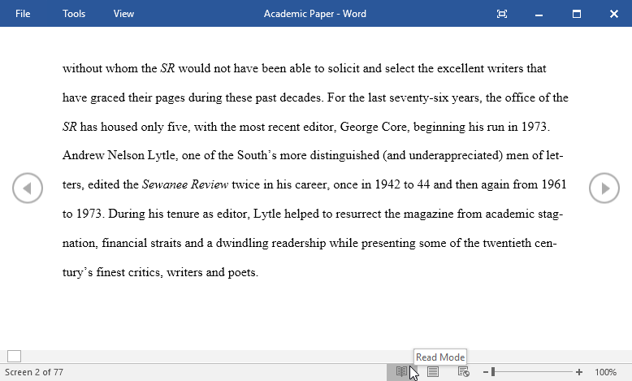

* **Print Layout**: This is the default document view in Word. It shows what the document will look like on the printed page.

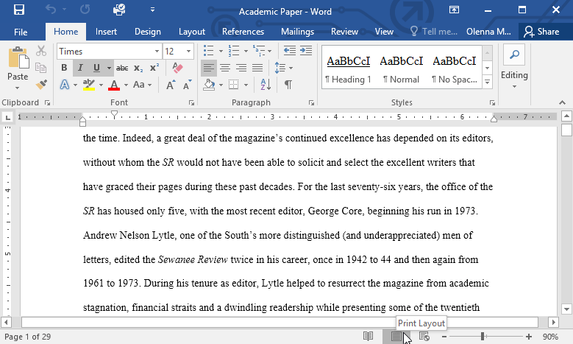

* **Web Layout**: This view displays the document as a webpage, which can be helpful if you're using Word to publish content online.

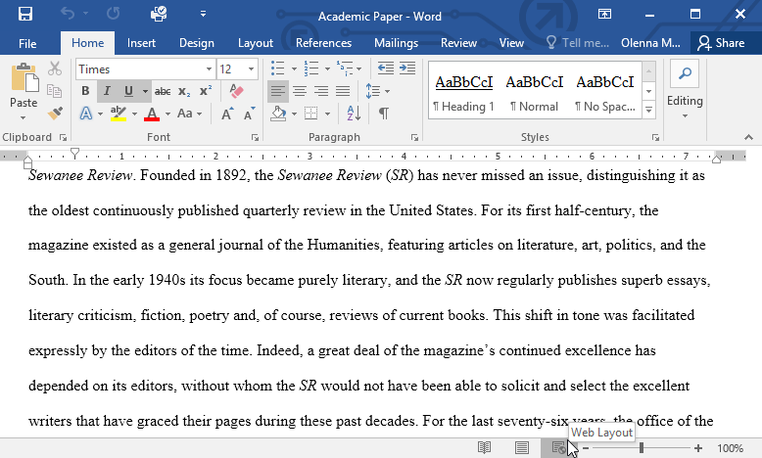

Zooming in and out

To zoom in or out, click and drag the **zoom control slider** in the bottom-right corner of the Word window. You can also select the **+** or **-** **commands** to zoom in or out by smaller increments. The number next to the slider displays the current**zoom percentage**, also called the **zoom level**.

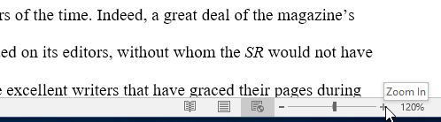

Task

1. Open **Word 2016**, and create a **blank document**.
2. Change the **Ribbon Display Options** to **Show Tabs**.
3. Using **Customize Quick Access Toolbar**, add **New**, **Quick Print**, and **Spelling & Grammar.**
4. In the **Tell me bar**, type **Shape** and press **Enter**.
5. Choose a shape from the menu, and double-click somewhere on your document.
6. Show the **Ruler** if it is not already visible.
7. **Zoom**the document to 120%.
8. Change the **Document view** to **Web Layout**.
9. When you're finished, your document should look something like this:

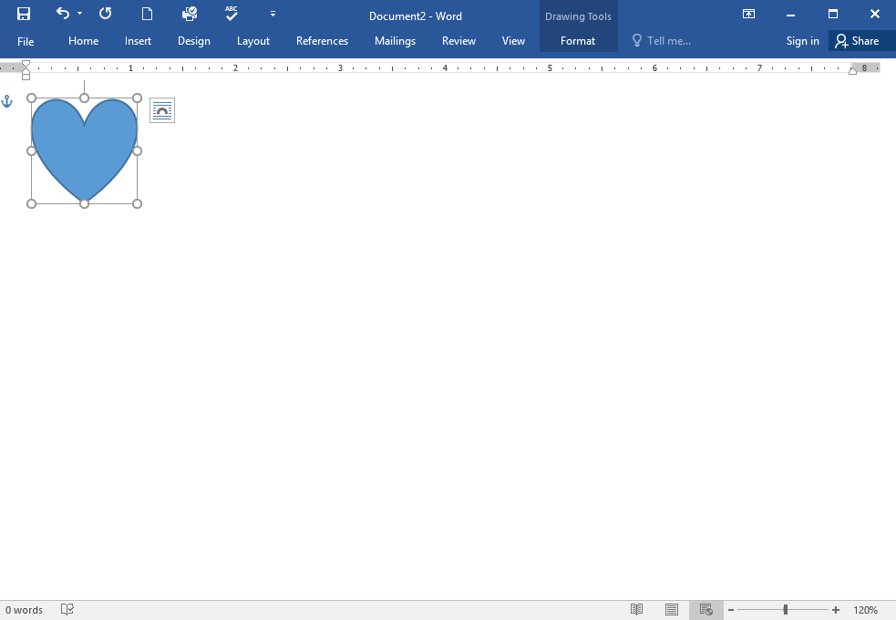

1. Change the **Ribbon Display Options** back to **Show Tabs and Commands**, and change the **Document View** back to **Print Layout**.

**Word 2016**

**Understanding OneDrive**

Introduction

Many of the features in Office are geared toward saving and sharing files online. **OneDrive** is Microsoft’s online storage space that you can use to save, edit, and share your documents and other files. You can access OneDrive from your computer, smartphone, or any of the devices you use.

To get started with OneDrive, all you need to do is set up a free **Microsoft account**, if you don’t already have one.

If you don't already have a Microsoft account, you can go to the [**Creating a Microsoft Account**](http://www.gcflearnfree.org/microsoftaccount/creating-a-microsoft-account/2/) lesson in our Microsoft Account tutorial.

Once you have a Microsoft account, you'll be able to sign in to Office. Just click **Sign in** in the upper-right corner of the Word window.

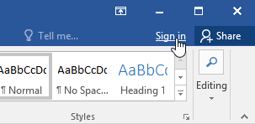

Benefits of using OneDrive

Once you’re signed in to your Microsoft account, here are a few of the things you’ll be able to do with OneDrive:

* **Access your files anywhere:** When you save your files to OneDrive, you’ll be able to access them from any computer, tablet, or smartphone that has an Internet connection. You'll also be able to create new documents from OneDrive.
* **Back up your files:** Saving files to OneDrive gives them an extra layer of protection. Even if something happens to your computer, OneDrive will keep your files safe and accessible.
* **Share files:** It’s easy to share your OneDrive files with friends and coworkers. You can choose whether they can edit or simply read files. This option is great for collaboration because multiple people can edit a document at the same time (also known as co-authoring).

Saving and opening files

When you’re signed in to your Microsoft account, OneDrive will appear as an option whenever you save or open a file. You still have the option of saving files to your computer. However, saving files to your OneDrive allows you to access them from any other computer, and it also allows you to share files with friends and coworkers.

For example, when you click **Save As**, you can select either OneDrive or This PC as the save location.

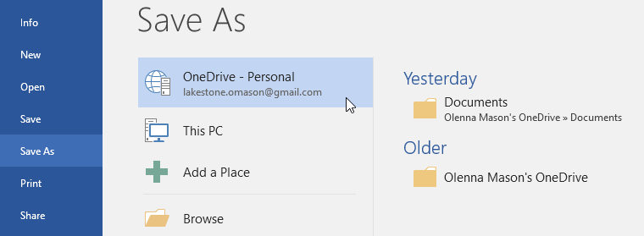

To convert a document:

If you want access to all Word 2016 features, you can **convert** the document to the 2016 file format.

1. Click the **File** tab to access Backstage view, then locate and select the **Convert** command.

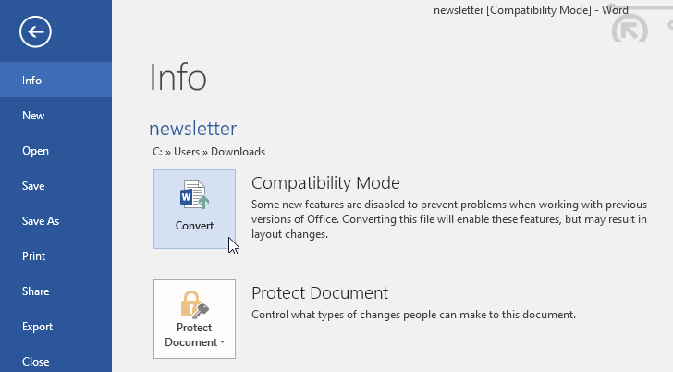

1. A dialog box will appear. Click **OK** to confirm the file upgrade.

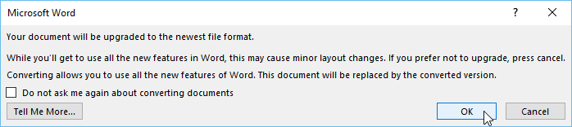

1. The document will be converted to the newest file type.

Converting a file may cause some changes to the **original layout** of the document.

#### To create a new document from a template:

A **template** is a **predesigned document** you can use to create a new document quickly. Templates often include **custom formatting** and **designs**, so they can save you a lot of time and effort when starting a new project.

1. Click the **File** tab to access **Backstage view**, then select **New**.
2. Several templates will appear below the **Blank document** option. You can also use the search bar to find something more specific. In our example, we'll search for a **flyer** template.

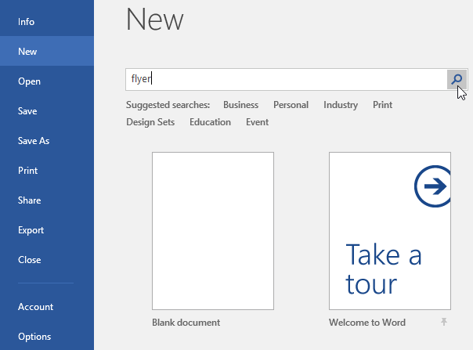

1. When you find something you like, select a template to preview it.

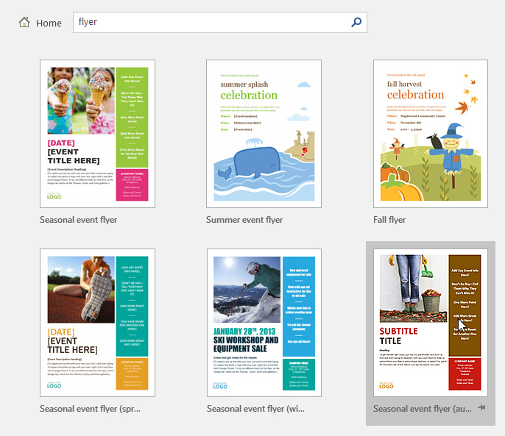

1. A **preview** of the template will appear. Click **Create** to use the selected template.

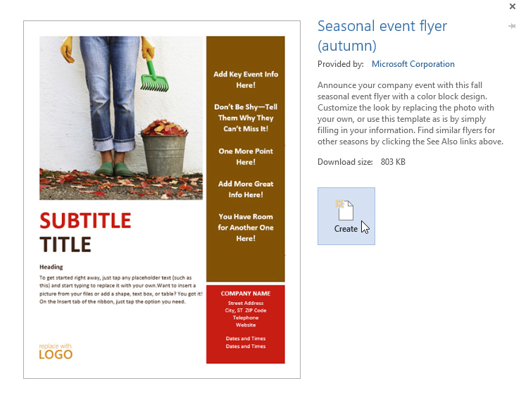

1. A new document will appear with the **selected template**.

You can also browse templates by category after performing a search.

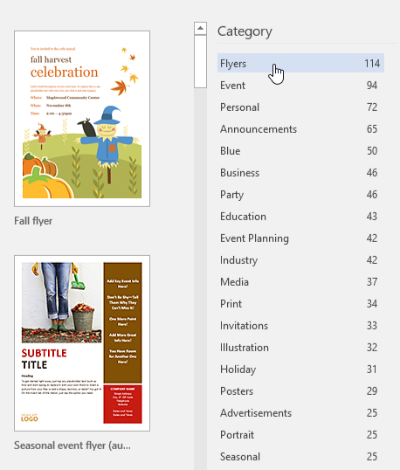

#### To open an existing document:

In addition to creating new documents, you'll often need to open a document that was previously saved. To learn more about saving documents, visit our lesson on [**Saving and Sharing Documents**](http://www.gcflearnfree.org/word2016/saving-and-sharing-documents/1/).

1. Navigate to **Backstage view**, then click **Open**.

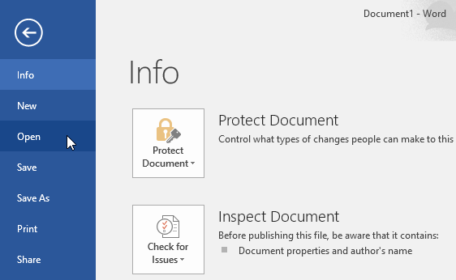

1. Select **This PC**, then click **Browse**. Alternatively, you can choose **OneDrive** to open files stored on your OneDrive.

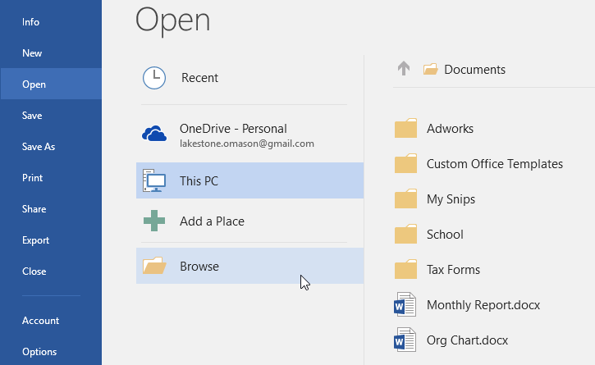

1. The **Open** dialog box will appear. Locate and select your **document**, then click **Open**.

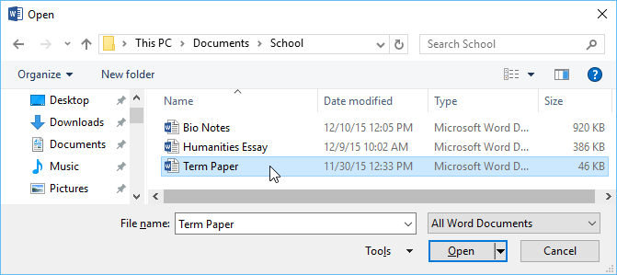

1. The selected document will appear.

#### To export a document as a PDF file:

Exporting your document as an **Adobe Acrobat document**, commonly known as a **PDF file**, can be especially useful if you're sharing a document with someone who does not have Word. A PDF file will make it possible for recipients to view—but not edit—the content of your document.

1. Click the **File** tab to access **Backstage** **view**, choose **Export**, then select **Create PDF/XPS**.

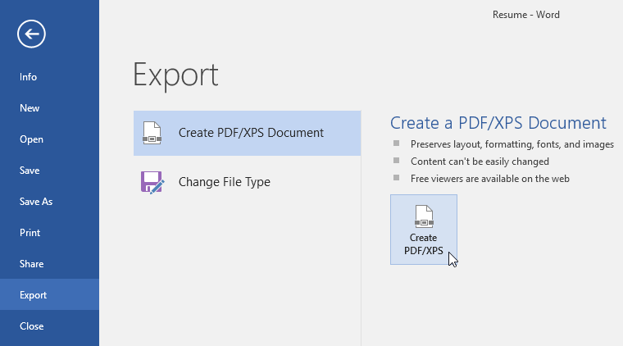

1. The **Save As**dialog box will appear. Select the **location** where you want to export the document, enter a **file name**, and then click**Publish.**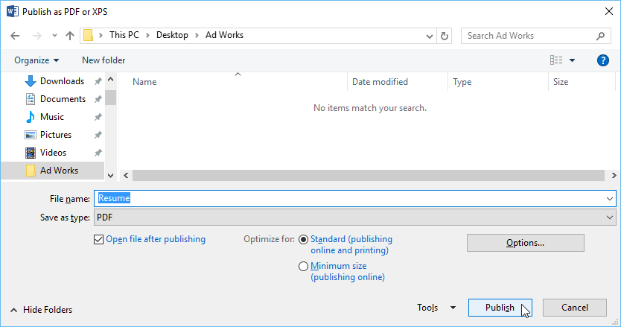

If you need to edit a PDF file, Word allows you to convert a PDF file into an editable document. Read our guide on [**Editing PDF Files**](http://www.gcflearnfree.org/word2013/editing-pdf-files/1/) for more information.

#### To export a document to other file types:

You may also find it helpful to export your document to other file types, such as a **Word 97-2003 Document** if you need to share with people using an older version of Word or as a **.txt file** if you need a**plain-text** version of your document.

1. Click the **File** tab to access **Backstage** **view**, choose **Export**, then select **Change File Type**.

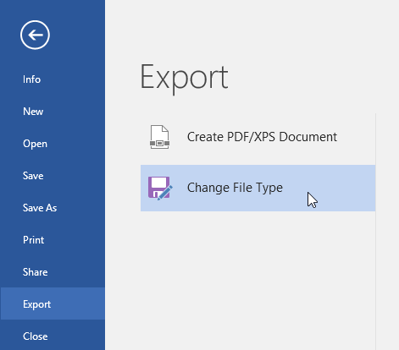

1. Select a **file** **type**, then click **Save** **As**.

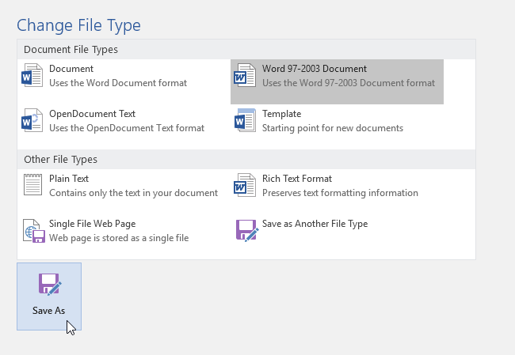

1. The **Save As**dialog box will appear. Select the **location** where you want to export the document, enter a **file name**, and then click **Save**.

**Formatting text**

To change the font size:

1. Select the text you want to modify.

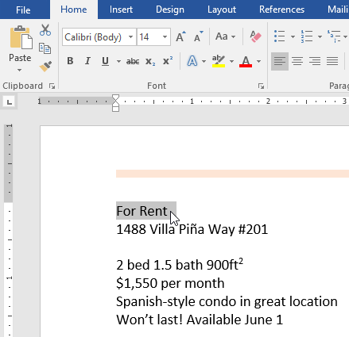

1. On the **Home** tab, click the Font size drop-down arrow. Select a font size from the menu. If the font size you need is not available in the menu, you can click the Font size box and **type** the desired font size, then press **Enter**.

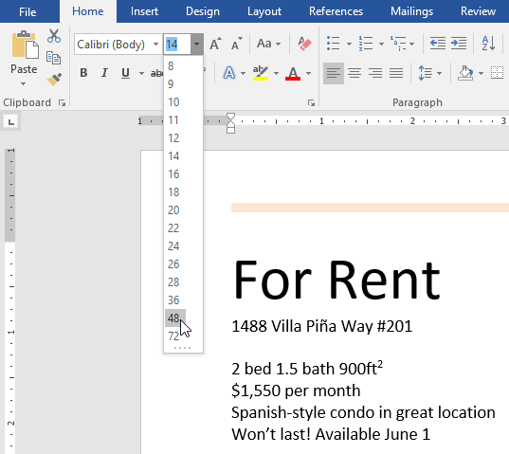

1. The font size will change in the document.

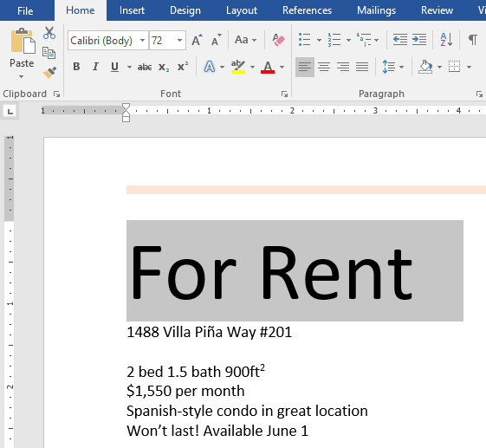

You can also use the **Grow Font** and **Shrink Font** commands to change the font size.

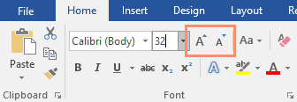

To change the font:

By default, the font of each new document is set to Calibri. However, Word provides many other fonts you can use to customize text.

1. Select the text you want to modify.

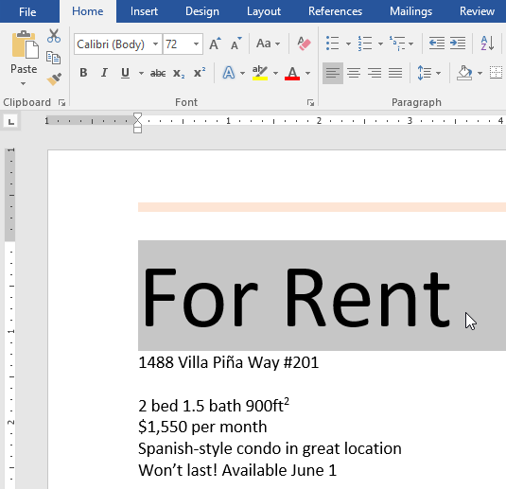

1. On the **Home** tab, click the **drop-down arrow** next to the **Font** box. A menu of font styles will appear.
2. Select the font style you want to use.

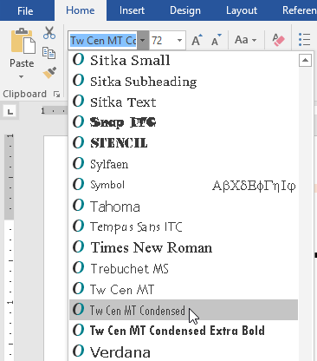

1. The font will change in the document.

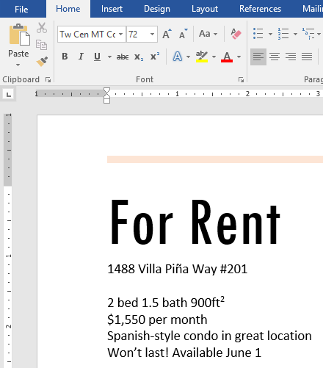

When creating a professional document or a document that contains multiple paragraphs, you'll want to select a font that's easy to read. Along with Calibri, standard reading fonts include Cambria, Times New Roman, and Arial.

To change the font color:

1. Select the text you want to modify.

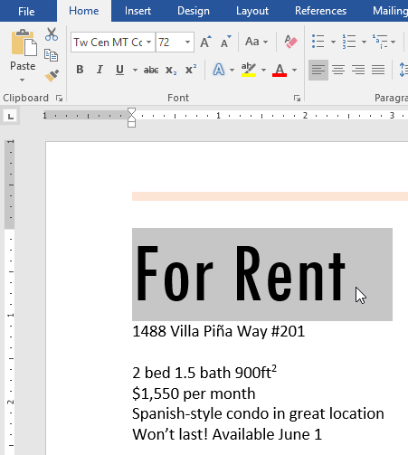

1. On the **Home** tab, click the **Font Color** drop-down arrow. The **Font Color** menu appears.

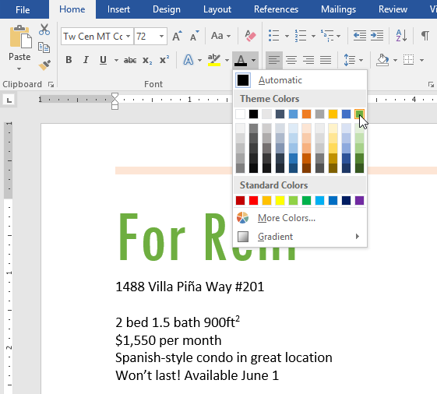

1. Select the font color you want to use. The font color will change in the document.

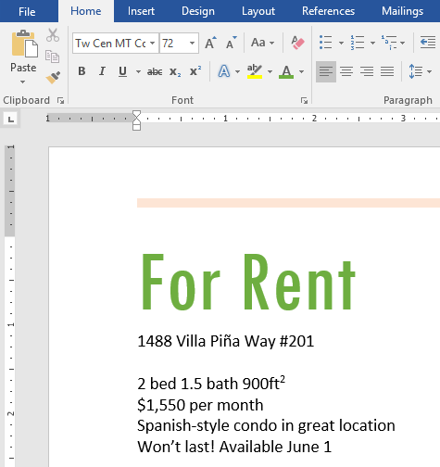

Your color choices aren't limited to the drop-down menu that appears. Select **More Colors** at the bottom of the menu to access the **Colors** dialog box. Choose the color you want, then click **OK**.

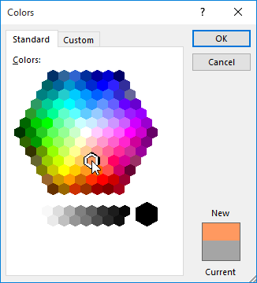

To use the Bold, Italic, and Underline commands:

The Bold, Italic, and Underline commands can be used to help draw attention to important words or phrases.

1. Select the text you want to modify.

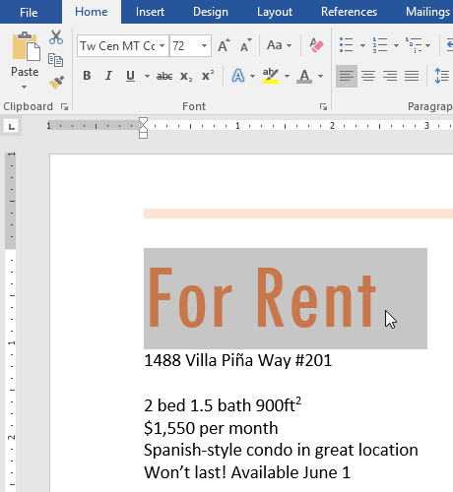

1. On the Home tab, click the Bold (**B**), Italic (*I*), or Underline (U) command in the **Font** group. In our example, we'll click Bold.

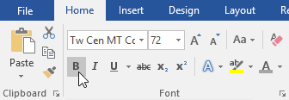

1. The selected text will be modified in the document.

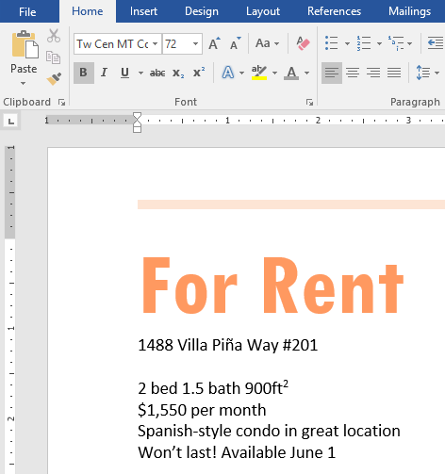

To change text case:

When you need to quickly change text case, you can use the **Change Case** command instead of deleting and retyping text.

1. Select the text you want to modify.

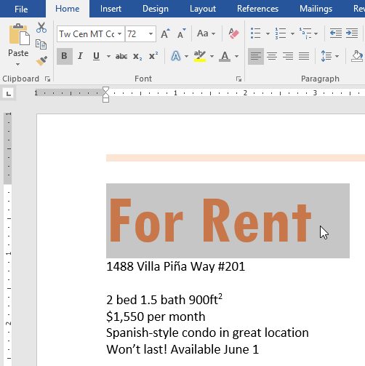

1. On the Home tab, click the **Change Case** command in the **Font** group.
2. A drop-down menu will appear. Select the desired case option from the menu.

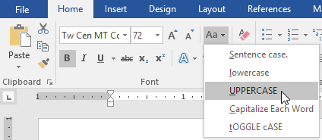

1. The text case will be changed in the document.

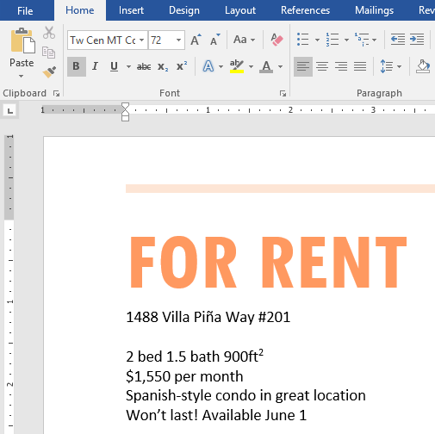

To highlight text:

Highlighting can be a useful tool for marking important text in your document.

1. Select the text you want to highlight.

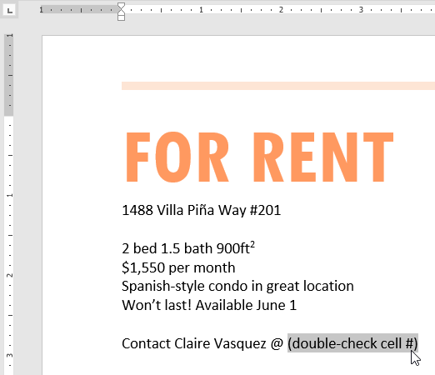

1. From the **Home** tab, click the **Text Highlight Color** drop-down arrow. The **Highlight Color** menu appears.

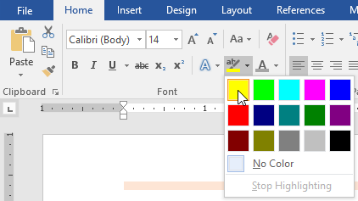

1. Select the desired highlight**color**. The selected text will then be highlighted in the document.

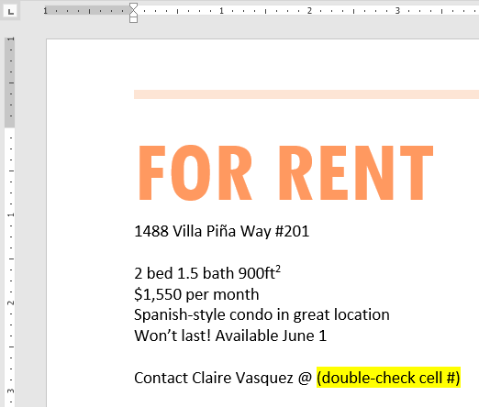

To remove highlighting, select the highlighted text, then click the **Text Highlight Color** drop-down arrow. Select **No Color** from the drop-down menu.

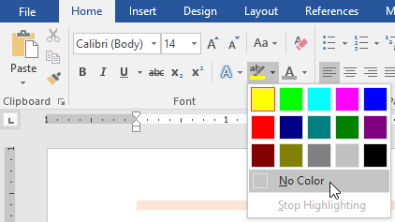

If you need to highlight several lines of text, changing the mouse into a **highlighter** may be a helpful alternative to selecting and highlighting individual lines. Click the **Text Highlight Color** command, and the cursor changes into a highlighter. You can then click, hold, and drag the highlighter over the lines you want to highlight.

To change text alignment:

By default, Word aligns text to the **left margin** in new documents. However, there may be times when you want to adjust text alignment to the center or right.

1. Select the text you want to modify.

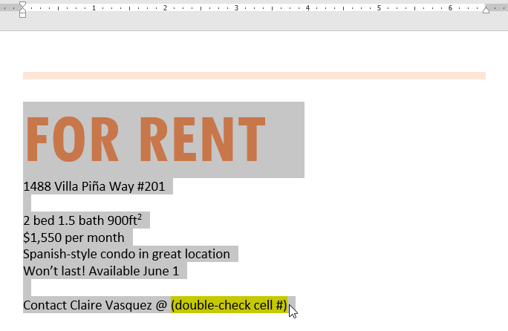

1. On the **Home** tab, select one of the four alignment options from the **Paragraph** group. In our example, we've selected **Center Alignment**.

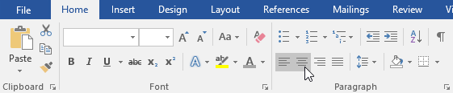

1. The text will be realigned in the document.

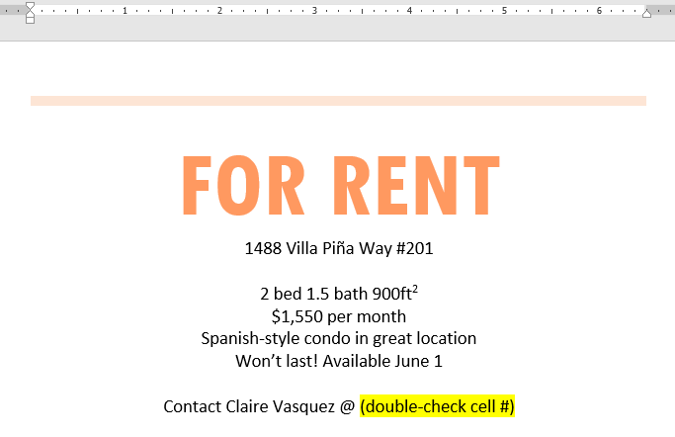

## **Using Find and Replace**

To find text

In our example, we've written an academic paper and will use the Find command to locate all instances of a particular word.

1. From the **Home**tab, click the **Find** command. Alternatively, you can press **Ctrl+F** on your keyboard.

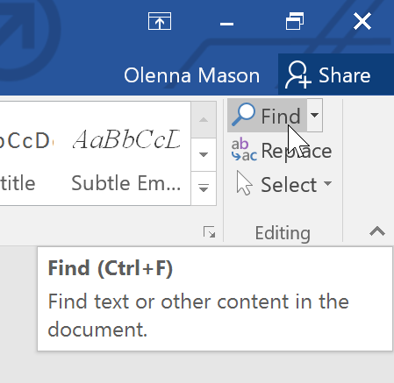

1. The **navigation pane** will appear on the left side of the screen.
2. Type the text you want to find in the field at the top of the navigation pane. In our example, we'll type the word we're looking for.

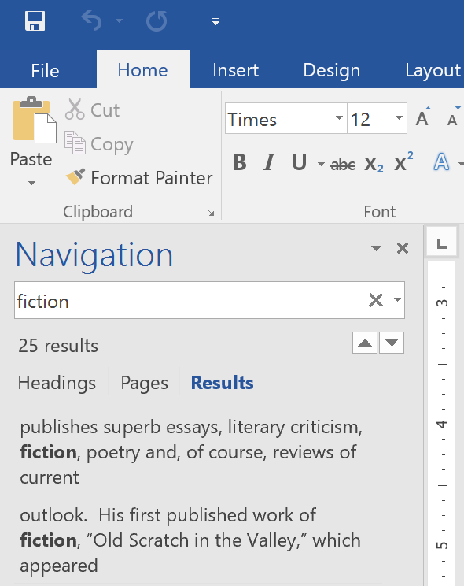

1. If the text is found in the document, it will be highlighted in yellow and a **preview of the results** will appear in the **navigation pane**. Alternatively, you can click one of the results below the arrows to jump to it.

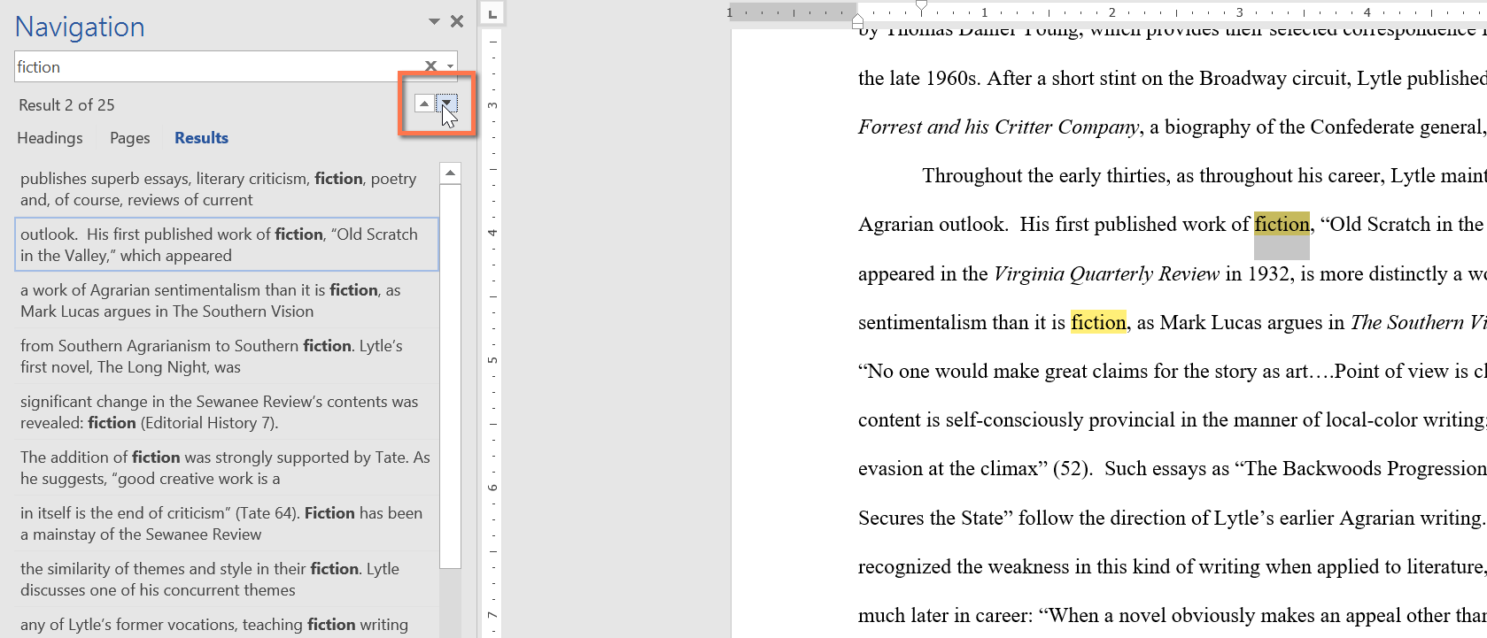

1. When you are finished, click the **X** to close the navigation pane. The highlight will disappear.

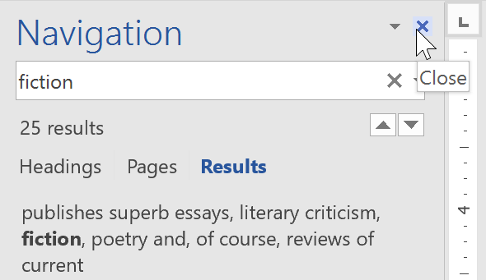

For more search options, click the drop-down arrow next to the search field.

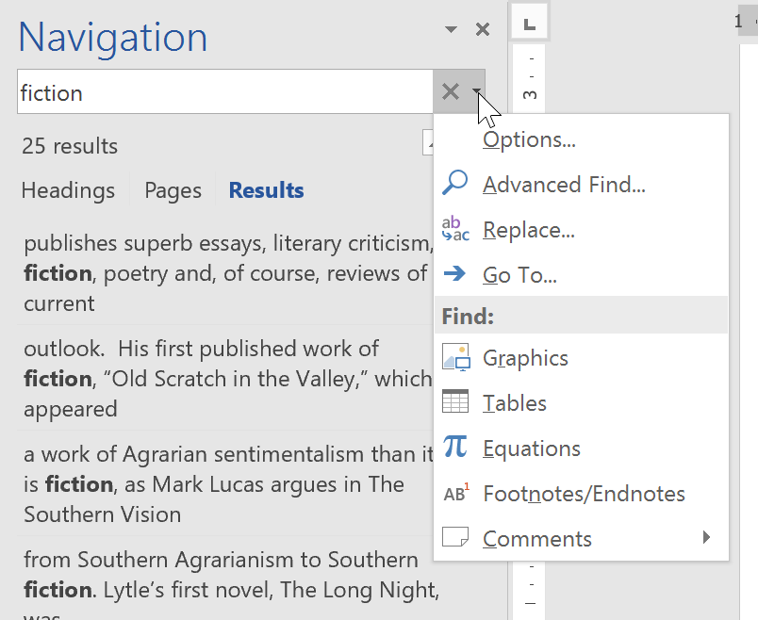

To replace text

At times, you may discover that you've made a mistake repeatedly throughout your document—such as misspelling a person's name—or that you need to exchange a particular word or phrase for another. You can use Word's **Find and Replace** feature to quickly make revisions. In our example, we'll use Find and Replace to change the title of a magazine so it is abbreviated.

1. From the **Home** tab, click the **Replace** command. Alternatively, you can press **Ctrl+H** on your keyboard.

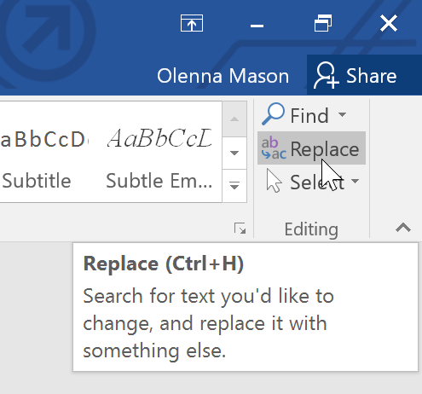

1. The **Find and Replace** dialog box will appear.
2. Type the text you want to find in the **Find what:** field.
3. Type the text you want to replace it with in the **Replace with:** field. Then click **Find Next**.

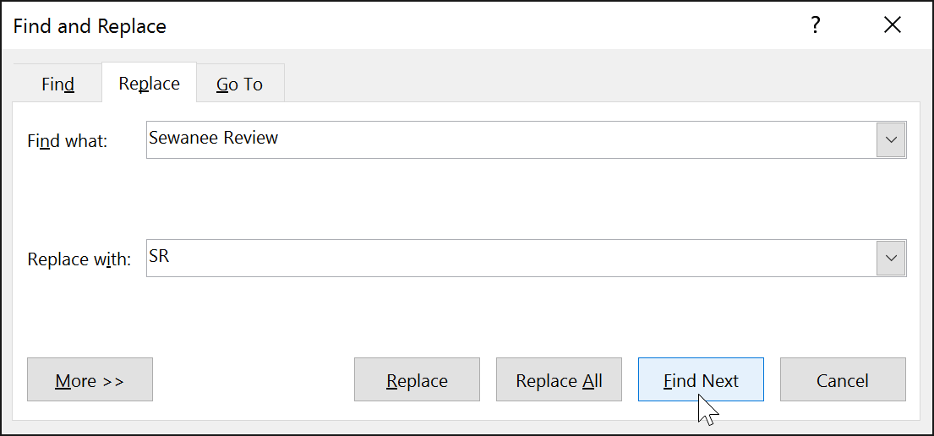

1. Word will find the first instance of the text and **highlight** it in gray.
2. **Review** the text to make sure you want to replace it. In our example, the text is part of the title of the paper and does not need to be replaced. We'll click **Find Next** again to jump to the next instance.

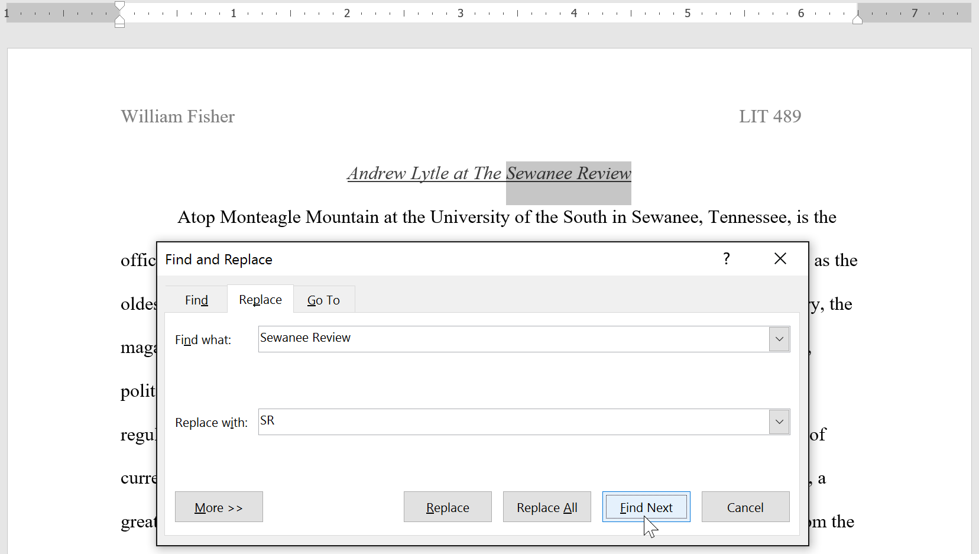

1. If you want to replace it, you can click **Replace** to change individual instances of text. Alternatively, you can click **Replace All** to replace every instance of the text throughout the document.

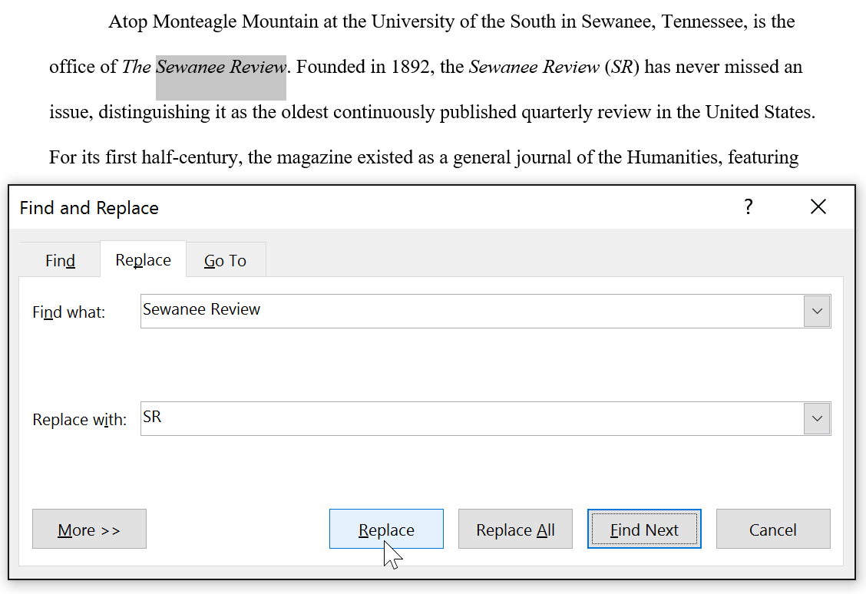

1. The text will be replaced.

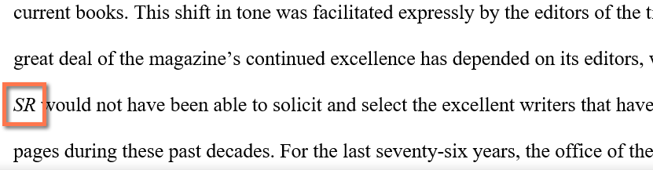

1. When you're done, click **Close** or **Cancel** to close the dialog box.

For more search options, click **More** in the Find and Replace dialog box. From here, you can select additional search options, such as matching case and ignoring punctuation.

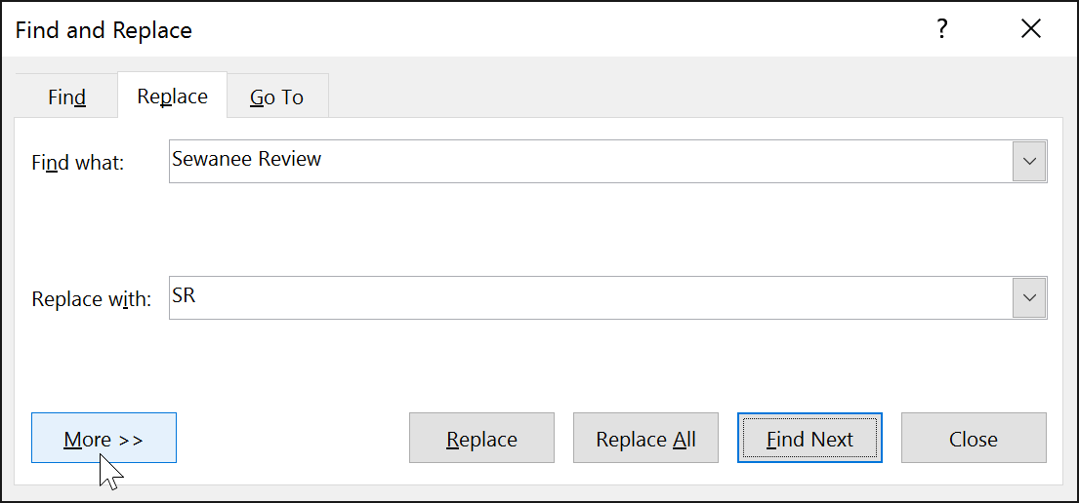

When it comes to using Replace All, it's important to remember that it could find matches you didn't anticipate and that you might not actually want to change. You should only use this option if you're absolutely sure it won't replace anything you didn't intend it to.

## **Line and Paragraph Spacing**

About line spacing

Line spacing is the **space between each line** in a paragraph. Word allows you to customize the line spacing to be **single spaced** (one line high), **double spaced** (two lines high), or any other amount you want. The default spacing in Word is **1.08 lines**, which is slightly larger than single spaced.

In the images below, you can compare different types of line spacing. From left to right, these images show default line spacing, single spacing, and double spacing.

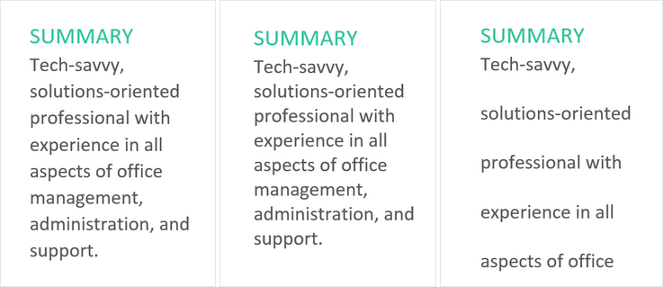

Line spacing is also known as leading (pronounced to rhyme with **wedding**).

To format line spacing

1. Select the text you want to format.



1. On the **Home** tab, click the **Line and Paragraph Spacing** command, then select the desired line spacing.

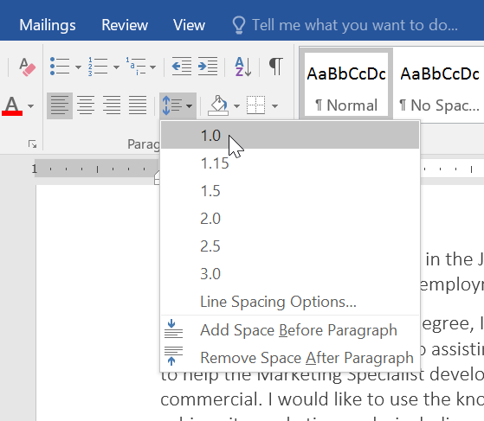

1. The line spacing will change in the document.



Fine tuning line spacing

Your line spacing options aren't limited to the ones in the **Line and Paragraph Spacing** menu. To adjust spacing with more precision, select **Line Spacing Options**from the menu to access the **Paragraph** dialog box. You'll then have a few additional options you can use to customize spacing.

* **Exactly**:When you choose this option, the line spacing is **measured in points**, just like font size. For example, if you're using **12-point** text, you could use **15-point** spacing.
* **At least**: Like the the **Exactly** option, this lets you choose how many points of spacing you want. However, if you have different sizes of text on the same line, the spacing will expand to fit the larger text.
* **Multiple**: This option lets you type the number of lines of spacing you want. For example, choosing **Multiple** and changing the spacing to **1.2**will make the text slightly more spread out than single-spaced text. If you want the lines to be closer together, you can choose a smaller value, like**0.9**.

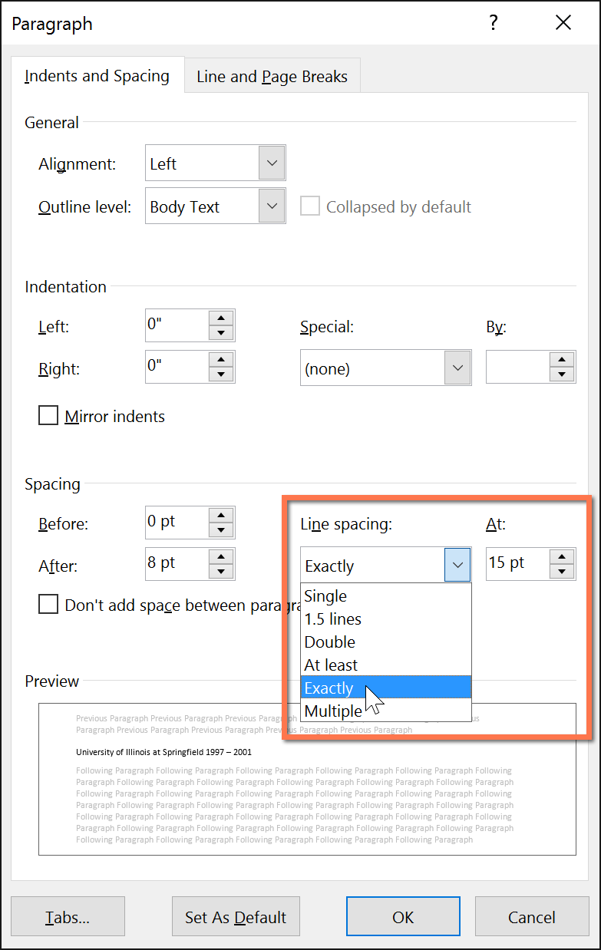

Paragraph spacing

Just as you can format spacing between lines in your document, you can adjust spacing before and after paragraphs. This is useful for separating paragraphs, headings, and subheadings.

To format paragraph spacing:

In our example, we'll increase the space before each paragraph to separate them a bit more. This will make it a little easier to read.

1. Select the paragraph or paragraphs you want to format.



1. On the **Home** tab, click the **Line and Paragraph Spacing** command. Click **Add Space Before Paragraph** or **Remove Space After Paragraph** from the drop-down menu. In our example, we'll select **Add Space Before Paragraph**.

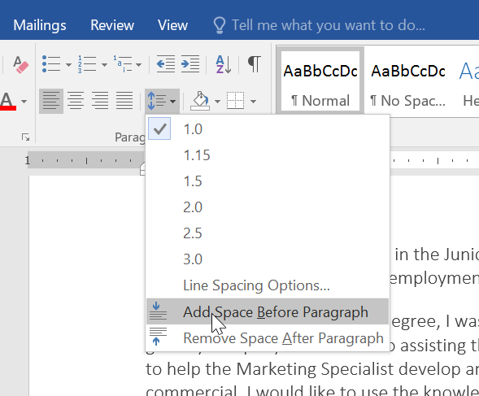

1. The paragraph spacing will change in the document.



From the drop-down menu, you can also select **Line Spacing Options**to open the Paragraph dialog box. From here, you can control how much space there is **before**and **after** the paragraph.

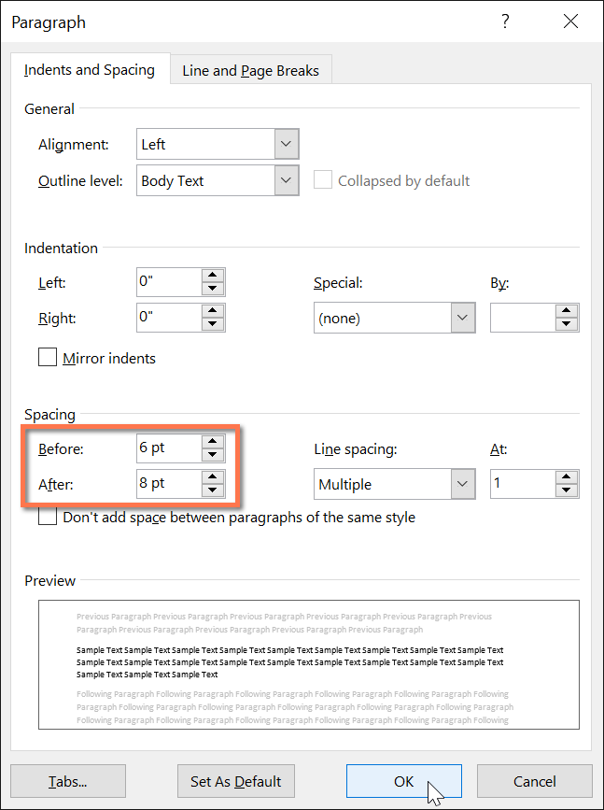

You can use Word's convenient **Set as Default**feature to **save** all of the **formatting**changes you've made and automatically apply them to new documents. To learn how to do this, read our article on [**Changing Your Default Settings in Word**](http://www.gcflearnfree.org/word-tips/changing-your-default-settings-in-word/1/).



## **Lists**

* [Options for working with lists](https://www.gcflearnfree.org/word2016/lists/1/#sidenav-lesson-1)
* [To create a numbered list](https://www.gcflearnfree.org/word2016/lists/1/#sidenav-lesson-2)
* [To restart a numbered list](https://www.gcflearnfree.org/word2016/lists/1/#sidenav-lesson-3)
* [**CUSTOMIZING BULLETS**](https://www.gcflearnfree.org/word2016/lists/1/#sidenav-lesson-4)
* [To use a symbol as a bullet](https://www.gcflearnfree.org/word2016/lists/1/#sidenav-lesson-5)
* [To change the bullet color](https://www.gcflearnfree.org/word2016/lists/1/#sidenav-lesson-6)
* [**MULTILEVEL LISTS**](https://www.gcflearnfree.org/word2016/lists/1/#sidenav-lesson-7)
* [To create a multilevel list](https://www.gcflearnfree.org/word2016/lists/1/#sidenav-lesson-8)

## **Hyperlinks**

### Introduction

Adding **hyperlinks** to text can provide access to **websites** and **email addresses** directly from your document. There are a few ways to insert a hyperlink into your document. Depending on how you want the link to appear, you can use Word's **automatic link formatting** or **convert** **text** into a link.

#### Understanding hyperlinks in Word

Hyperlinks have **two basic parts**: the address (URL) of the webpage and the **display text**. For example, the address could be [**http://www.popsci.com**](http://www.popsci.com/), and the display text could be **Popular Science Magazine**. When you create a hyperlink in Word, you'll be able to choose both the address and the display text.

Word often recognizes email and web addresses as you type and will automatically format them as hyperlinks after you press **Enter** or the **spacebar**. In the image below, you can see a hyperlinked web address.

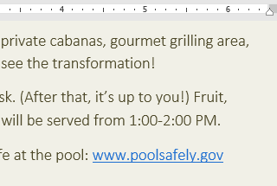

To follow a hyperlink in Word, hold the **Ctrl** key and click the **hyperlink**.

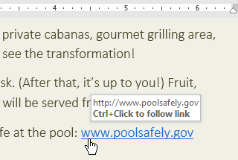

#### To format text with a hyperlink:

1. Select the text you want to format as a hyperlink.

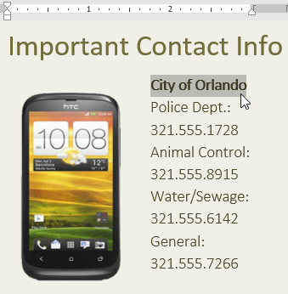

1. Select the **Insert** tab, then click the **Hyperlink** command.

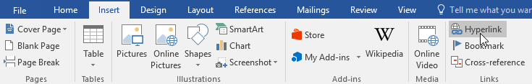

Alternatively, you can open the Insert Hyperlink dialog box by right-clicking the selected text and selecting **Hyperlink...** from the menu that appears.

1. The **Insert Hyperlink** dialog box will appear.
2. The selected text will appear in the **Text to display:** field at the top. You can change this text if you want.
3. In the **Address**: field, type the address you want to link to, then click **OK**.

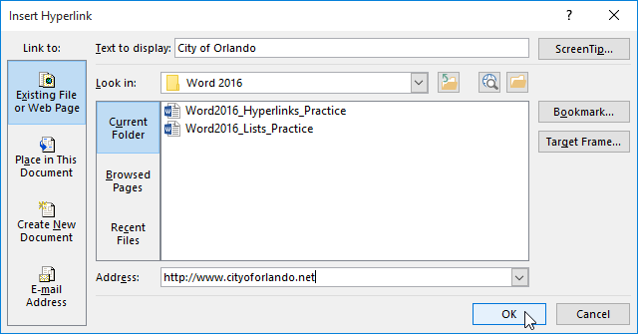

1. The text will then be formatted as a hyperlink.

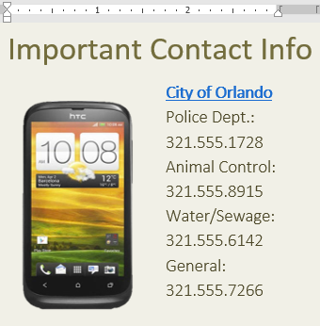

After you create a hyperlink, you should **test** it. If you've linked to a website, your web browser should automatically open and display the site. If it doesn't work, check the hyperlink address for misspellings.

#### Editing and removing hyperlinks

Once you've inserted a hyperlink, you can right-click the hyperlink to **edit**, **open**, **copy**, or **remove** it.

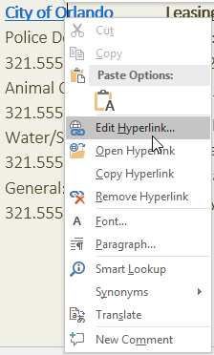

To remove a hyperlink, right-click the hyperlink and select **Remove Hyperlink** from the menu that appears.

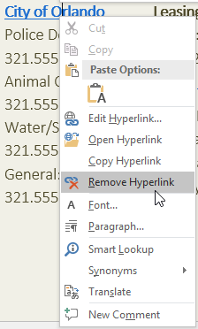

## **Page Layout**

#### Page orientation

Word offers two page orientation options:**landscape** and **portrait**. Compare our example below to see how orientation can affect the appearance and spacing of text and images.

* Landscape means the page is oriented **horizontally**.

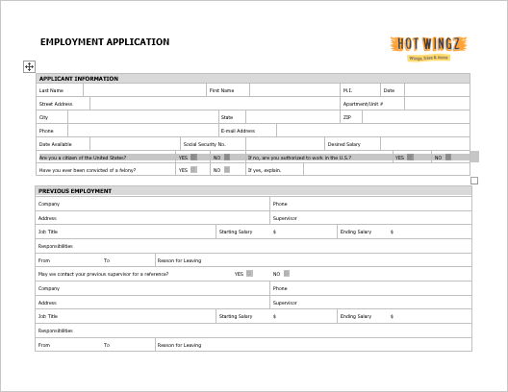

* Portrait means the page is oriented **vertically**.

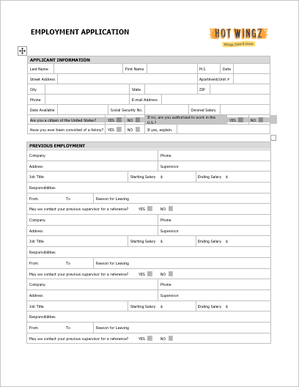

#### To change page orientation:

1. Select the **Layout** tab.
2. Click the **Orientation** command in the Page Setup group.

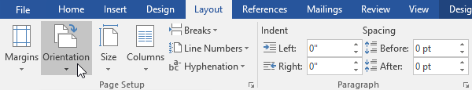

1. A drop-down menu will appear. Click either **Portrait** or **Landscape** to change the page orientation.

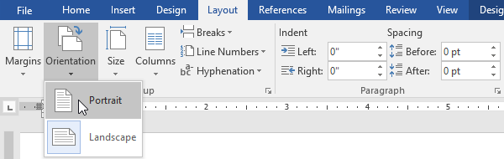

1. The page orientation of the document will be changed.

### Page size

By default, the **page size** of a new document is 8.5 inches by 11 inches. Depending on your project, you may need to adjust your document's page size. It's important to note that before modifying the default page size, you should check to see which page sizes your printer can accommodate.

#### To change the page size:

Word has a variety of **predefined page sizes** to choose from.

1. Select the **Layout** tab, then click the **Size** command.

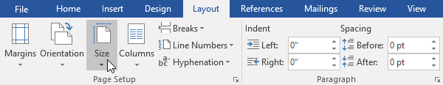

1. A drop-down menu will appear. The current page size is highlighted. Click the desired **predefined** **page size**.

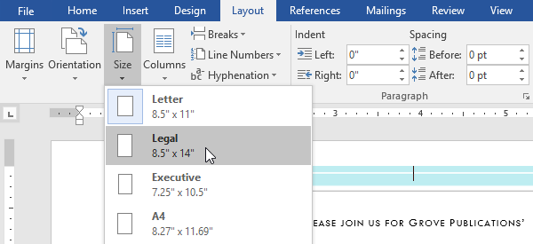

1. The page size of the document will be changed.

#### To use a custom page size:

Word also allows you to customize the page size in the **Page Setup** dialog box.

1. From the **Layout** tab, click **Size**. Select **More Paper Sizes** from the drop-down menu.

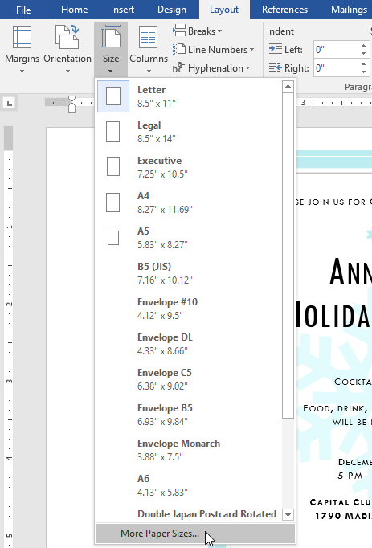

1. The**Page Setup** dialog box will appear.
2. Adjust the values for**Width** and **Height**, then click **OK**.

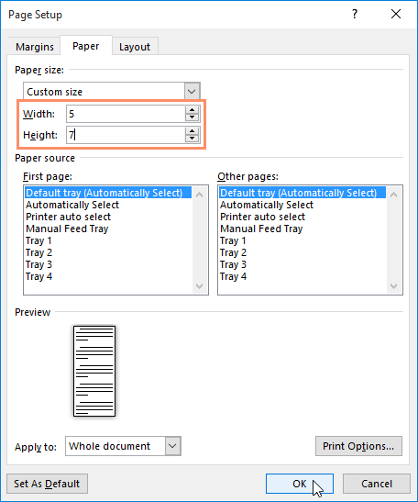

1. The page size of the document will be changed.

### Page margins

A **margin** is the **space** between the text and the edge of your document. By default, a new document's margins are set to **Normal**, which means it has a one-inch space between the text and each edge. Depending on your needs, Word allows you to change your document's margin size.

#### To format page margins:

Word has a variety of **predefined margin sizes** to choose from.

1. Select the **Layout** tab, then click the **Margins** command.

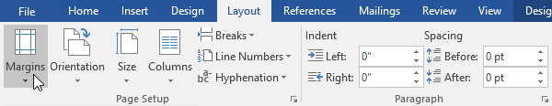

1. A drop-down menu will appear. Click the **predefined margin size** you want.

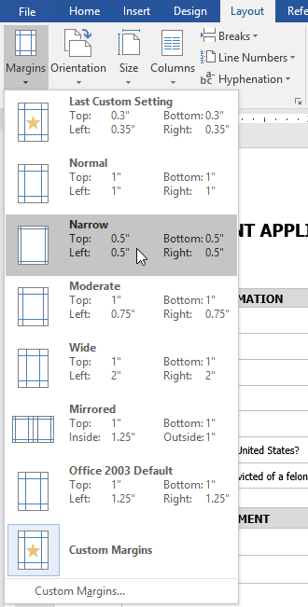

1. The margins of the document will be changed.

#### To use custom margins:

Word also allows you to customize the size of your margins in the **Page Setup** dialog box.

1. From the **Layout** tab, click **Margins**. Select **Custom Margins**from the drop-down menu.

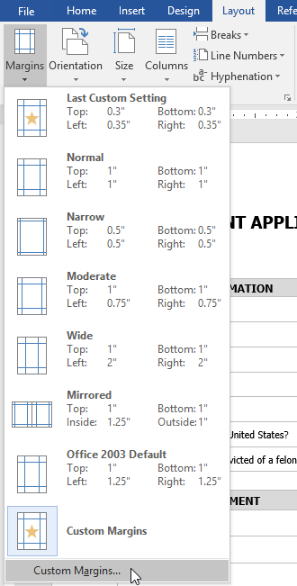

1. The **Page Setup** dialog box will appear.
2. Adjust the values for each margin, then click **OK**.

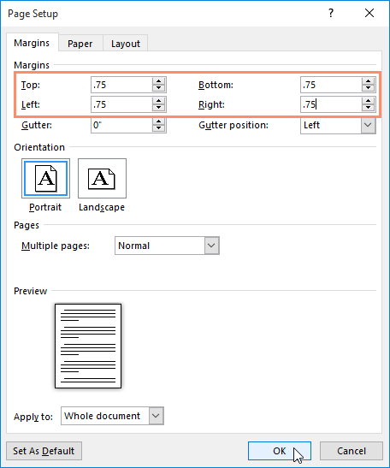

1. The margins of the document will be changed.

Alternatively, you can open the Page Setup dialog box by navigating to the Layout tab and clicking the small **arrow** in the bottom-right corner of the **Page Setup**group.

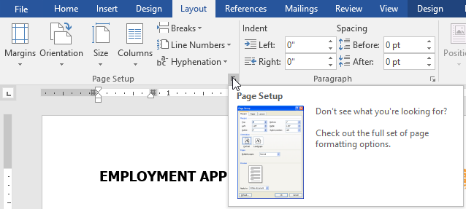

You can use Word's convenient **Set as Default** feature to **save** all of the **formatting**changes you've made and automatically apply them to new documents. To learn how to do this, read our article on [**Changing Your Default Settings in Word**](http://www.gcflearnfree.org/word-tips/changing-your-default-settings-in-word/1/).

## **Printing Documents**

## **Breaks**

When you're working on a multi-page document, there may be times when you want to have more control over how exactly the text flows. **Breaks** can be helpful in these cases. There are many types of breaks to choose from depending on what you need, including **page breaks**, **section breaks**, and **column breaks**.

#### To insert a page break:

In our example, the section headers on page three (**Monthly Revenue** and **By Client**) are separated from the table on the page below. And while we could just press **Enter** until that text reaches the top of page four, it could easily be shifted around if we added or deleted something in another part of the document. Instead, we'll insert a **page break**.

1. Place the **insertion point** where you want to create the page break. In our example, we'll place it at the beginning of our headings.

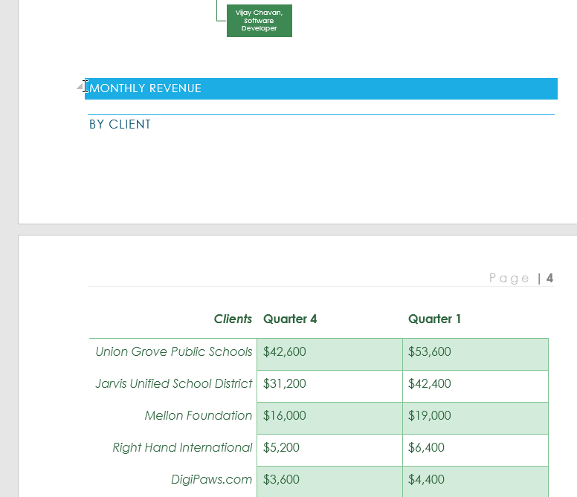

1. On the **Insert** tab, click the **Page Break** command. Alternatively, you can press **Ctrl+Enter** on your keyboard.

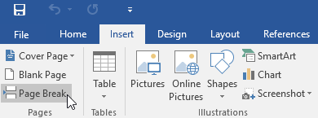

1. The page break will be inserted into the document, and the text will move to the next page.

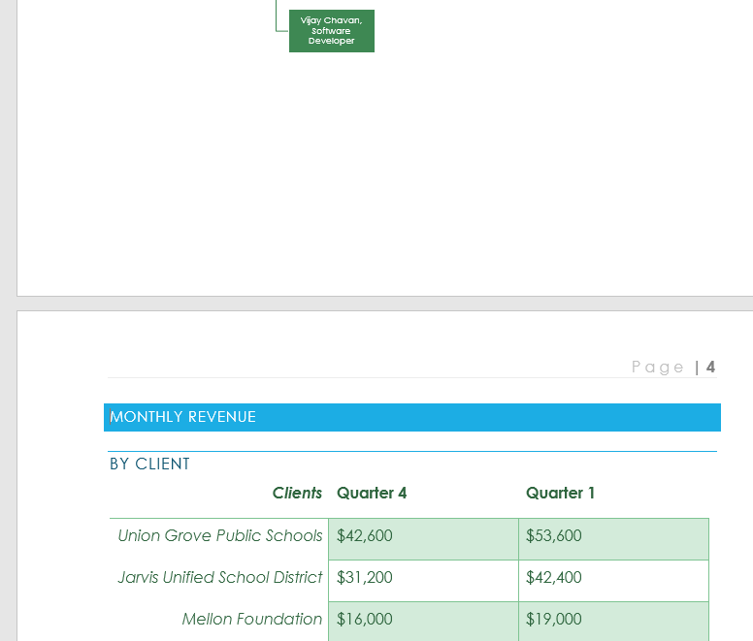

By default, breaks are **invisible**. If you want to see the breaks in your document, click the **Show/Hide** command on the **Home** tab.

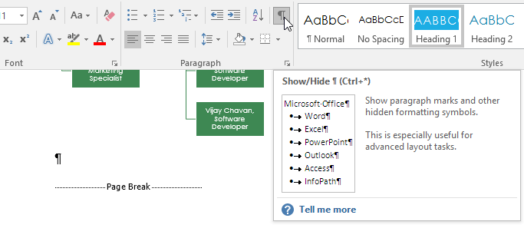

### Section breaks

**Section breaks** create a **barrier** between different parts of a document, allowing you to format each section independently. For example, you may want one section to have two columns without adding columns to the entire document. Word offers several types of section breaks.

* **Next Page**: This option inserts a section break and moves text after the break to the next page of the document.
* **Continuous**: This option inserts a section break and allows you to continue working on the same page.
* **Even Page** and **Odd Page**: These options add a section break and move the text after the break to the next even or odd page. These options may be useful when you need to begin a new section on an even or odd page (for example, a new chapter of a book).

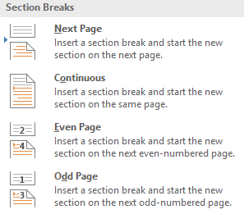

#### To insert a section break:

In our example, we'll add a section break to separate a paragraph from a two-column list.

1. Place the **insertion point** where you want to create the break. In our example, we'll place it at the beginning of the paragraph we want to separate from two-column formatting.

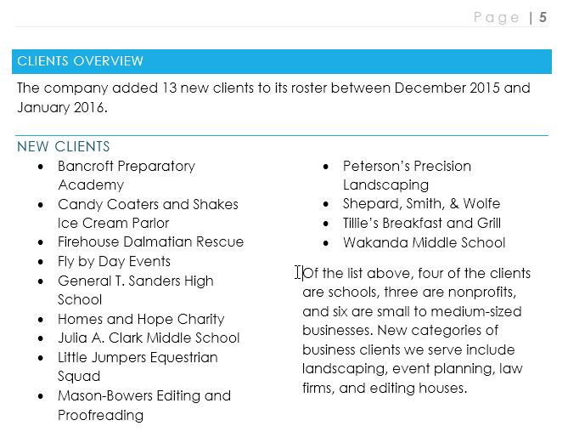

1. On the **Page Layout** tab, click the **Breaks** command, then select the desired section break from the drop-down menu. In our example, we'll select **Continuous**so our paragraph remains on the same page as the columns.

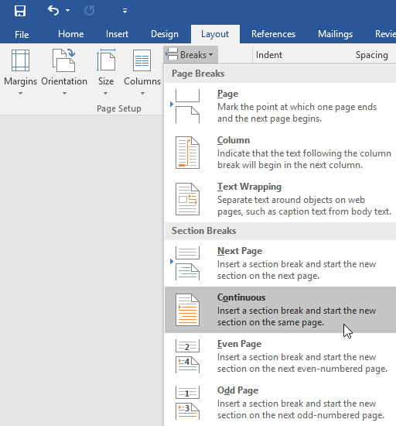

1. A section break will appear in the document.

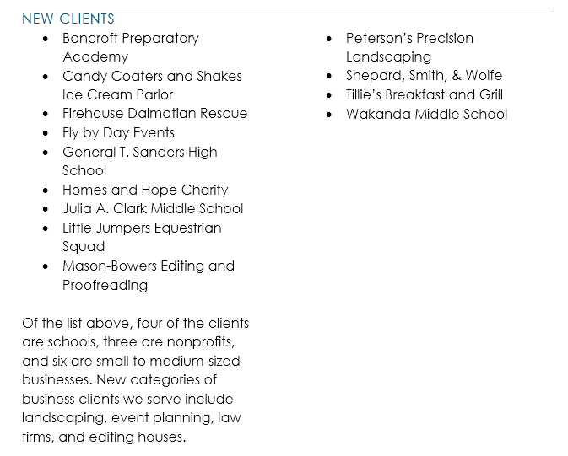

1. The text **before** and **after** the section break can now be formatted separately. In our example, we'll apply one-column formatting to the paragraph.

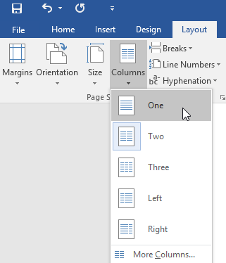

1. The formatting will be applied to the current section of the document. In our example, the text above the section break uses two-column formatting, while the paragraph below the break uses one-column formatting.

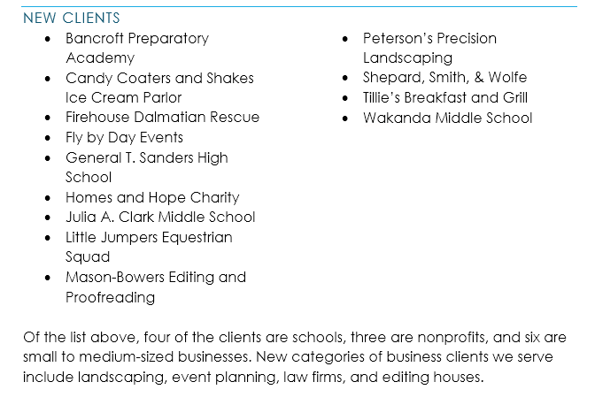

### Other types of breaks

When you want to format the appearance of columns or modify text wrapping around an image, Word offers additional break options that can help:

* **Column**: When creating multiple columns, you can apply a column break to balance the appearance of the columns. Any text following the column break will begin in the next column. To learn more about how to create columns in your document, visit our lesson on [**Columns**](http://www.gcflearnfree.org/word2016/columns/1/).
* **Text wrapping**: When text has been wrapped around an image or object, you can use a text-wrapping break to end the wrapping and begin typing on the line below the image. Review our lesson on [**Pictures and Text Wrapping**](http://www.gcflearnfree.org/word2016/pictures-and-text-wrapping/1/)to learn more.

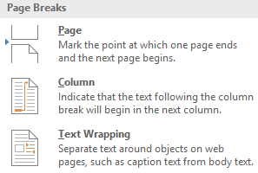

#### To delete a break:

By default, breaks are **hidden**. If you want to delete a break, you'll first need to show the breaks in your document.

1. On the **Home**tab, click the **Show/Hide**command.

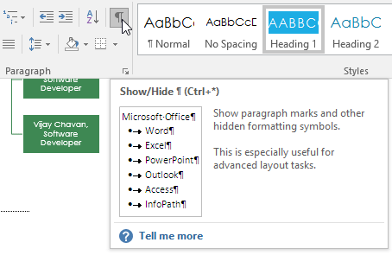

1. Locate the **break** you want to delete, then place the insertion point at the beginning of the break.

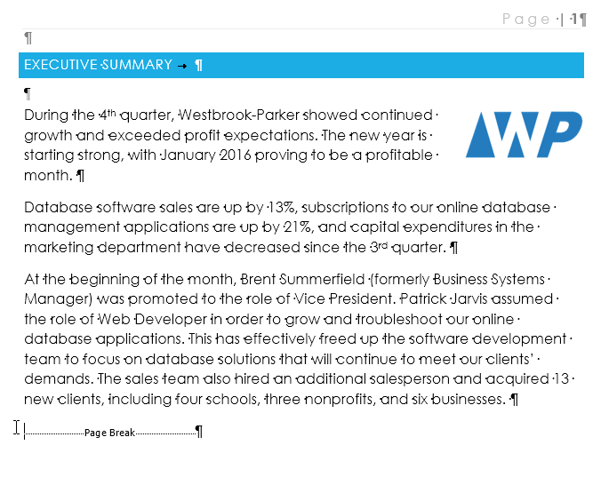

1. Press the **Delete** key. The break will be deleted from the document.



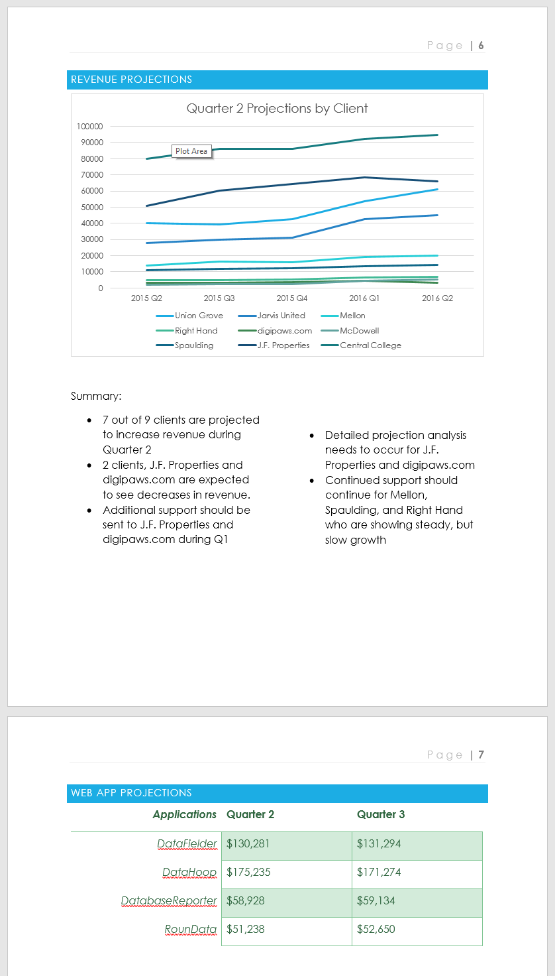

## **Headers and Footers**

### Introduction

The **header** is a section of the document that appears in the **top margin**, while the **footer** is a section of the document that appears in the **bottom margin**. Headers and footers generally contain additional information such as **page numbers**, **dates**, **anauthor's name**, and **footnotes**, which can help keep longer documents organized and make them easier to read. Text entered in the header or footer will appear on **each page** of the document.

#### To create a header or footer:

In our example, we want to display the author's name at the top of each page, so we'll place it in the header.

1. Double-click anywhere on the **top or bottom margin** of your document. In our example, we'll double-click the top margin.

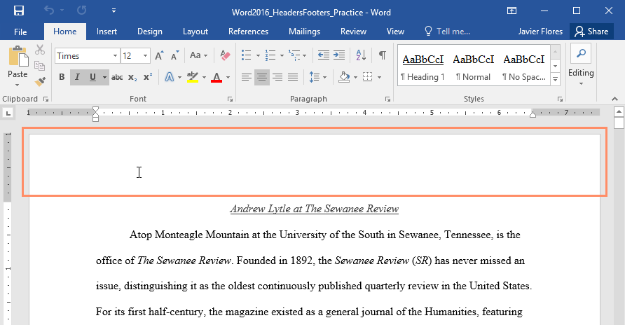

1. The header or footer will open, and a **Design** tab will appear on the right side of the**Ribbon**. The insertion point will appear in the header or footer.

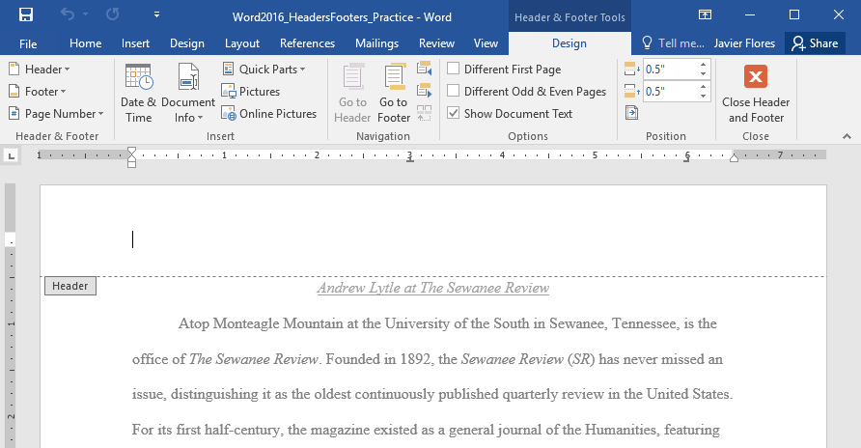

1. Type the**desired information** into the header or footer. In our example, we'll type the author's name and the date.

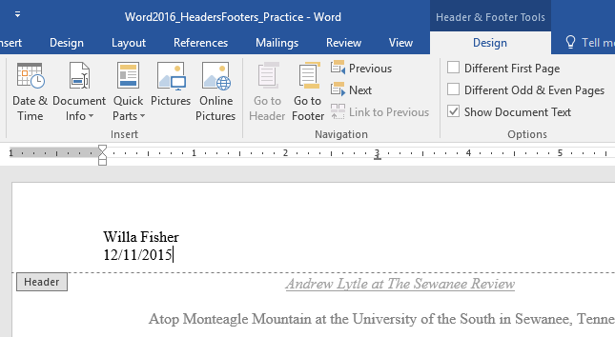

1. When you're finished, click **Close Header and Footer**. Alternatively, you can press the **Esc** key.

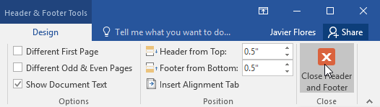

1. The header or footer text will appear.

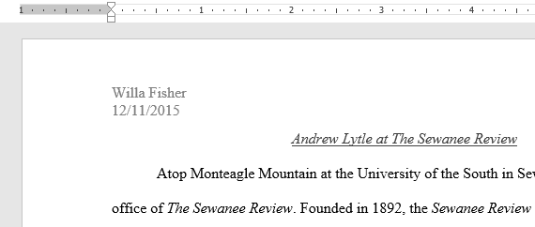

#### To insert a preset header or footer:

Word has a variety of **preset headers and footers** you can use to enhance your document's design and layout. In our example, we'll add a preset header to our document.

1. Select the **Insert** tab, then click the **Header** or **Footer** command. In our example, we'll click the **Header** command.

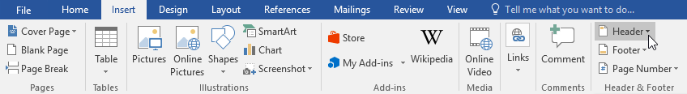

1. In the menu that appears, select the desired **preset header or footer**.

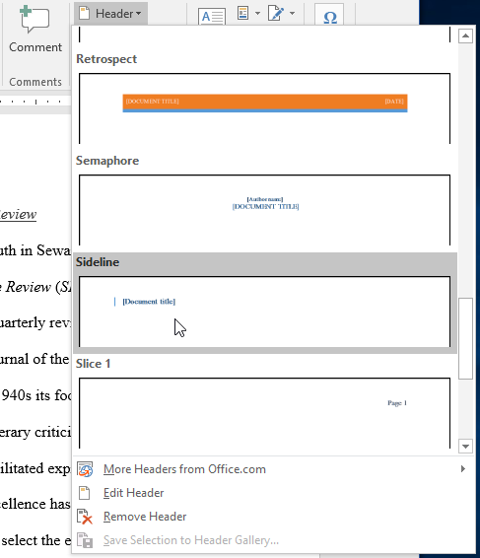

1. The header or footer will appear. Many preset headers and footers contain text placeholders called **Content Control** fields. These fields are good for adding information like the document title, author's name, date, and page number.

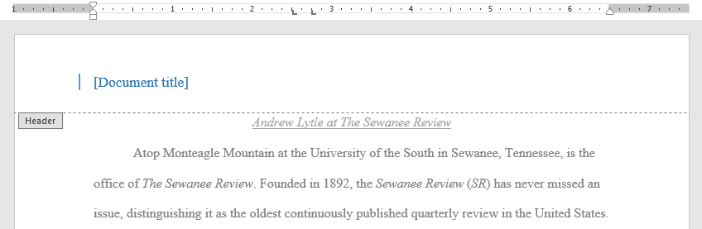

1. To edit a Content Control field, click it and type the **desired information**.

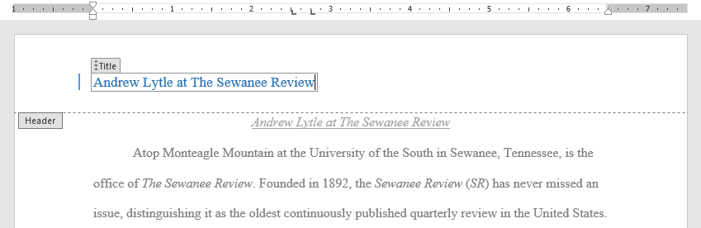

1. When you're finished, click **Close Header and Footer**. Alternatively, you can press the **Esc** key.



If you want to delete a Content Control field, right-click it and select **Remove Content Control** from the menu that appears.

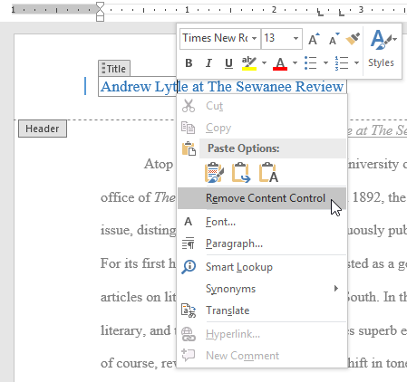

### Editing headers and footers

After you close the header or footer, it will still be visible, but it will be **locked**. Simply double-click a header or footer to **unlock** it, which will allow you to edit it.

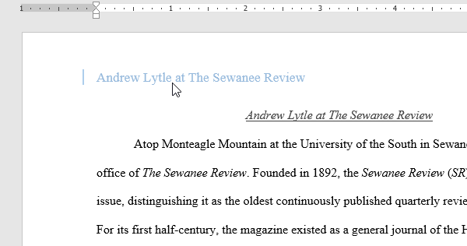

#### Design tab options

When your document's header and footer are unlocked, the **Design** tab will appear on the right side of the Ribbon, giving you various editing options:

* **Hide the first-page header and footer**: For some documents, you may not want the first page to show the header and footer, like if you have a cover page and want to start the page numbering on the second page. If you want to hide the first-page header and footer, check the box next to **Different First Page**.

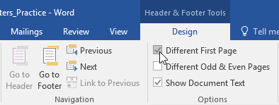

* **Remove the header or footer**: If you want to remove all information contained in the header, click the **Header** command and select **Remove Header** from the menu that appears. Similarly, you can remove a footer using the **Footer** command.

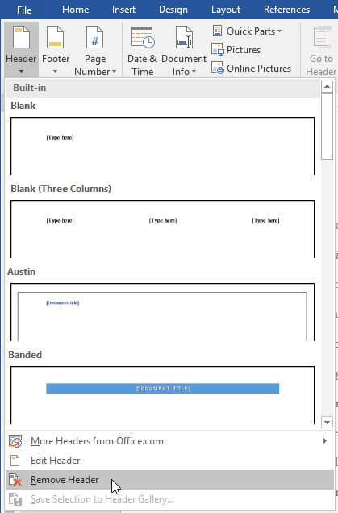

* **Page Number**: You can automatically number each page with the Page Number command. Read our [**Page Numbers**](http://www.gcflearnfree.org/word2016/page-numbers/1/) lesson to learn more.

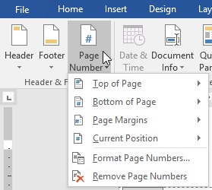

* **Additional options**: With the commands available in the Insert group, you can add the **date and time**, **document info**, **pictures**, and more to your header or footer.

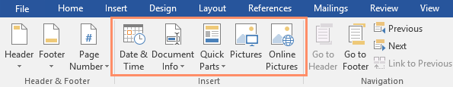

#### To insert the date or time into a header or footer:

Sometimes it's helpful to include the **date or time** in the header or footer. For example, you may want your document to show the **date when it was created**.

On the other hand, you may want to show the **date when it was printed**, which you can do by setting it to **update automatically**. This is useful if you frequently update and print a document because you'll always be able to tell which version is the most recent.

1. Double-click anywhere on the header or footer to **unlock** it. Place the **insertion point** where you want the date or time to appear. In our example, we'll place the insertion point on the line below the author's name.

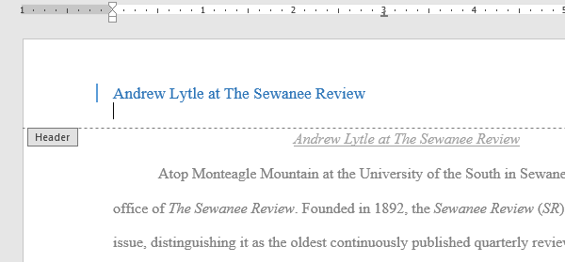

1. The **Design** tab will appear. Click the **Date & Time** command.

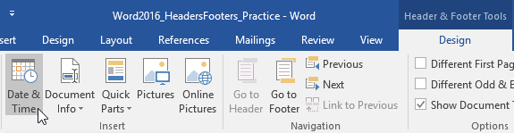

1. The **Date and Time** dialog box will appear. Select the desired **date**or **time format**.
2. Check the box next to **Update Automatically** if you want the date to change every time you open the document. If you don't want the date to change, leave this option unchecked.
3. Click **OK**.

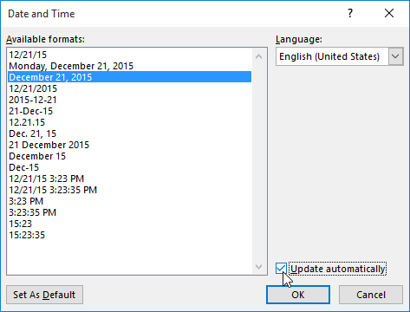

1. The date will appear in the header.

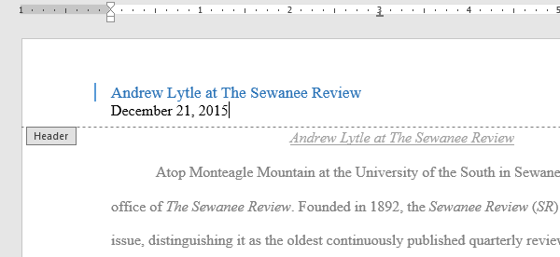

Formatting Pictures

#### To crop an image:

When you crop an image, part of the picture is **removed**. Cropping can be useful if you're working with an image that's too big and you want to focus on only **part** of it.

1. Select the image you want to crop. The **Format** tab will appear.
2. From the Format tab, click the **Crop** command.

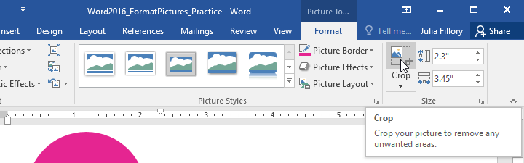

1. **Cropping handles** will appear on the sides and corners of the image. Click and drag **any handle** to crop the image. Because the cropping handles are near the resizing handles, be careful not to drag a resizing handle by mistake.

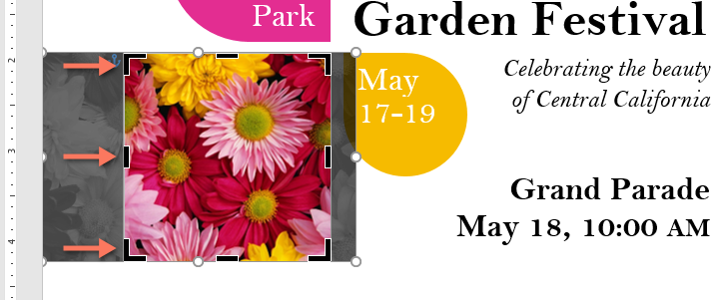

1. To confirm, click the **Crop** command again. The image will be cropped.

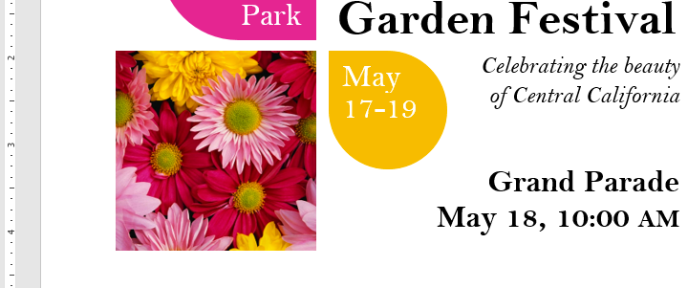

The corner handles are useful for simultaneously cropping the image **horizontally**and **vertically**.

#### To crop an image to a shape:

1. Select the image you want to crop, then click the **Format** tab.
2. Click the **Crop** drop-down arrow. Hover over **Crop to Shape**, then select the desired **shape**from the drop-down menu.

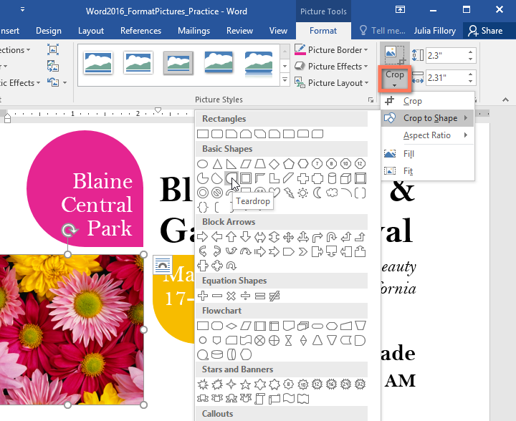

1. The image will be cropped to the chosen shape.

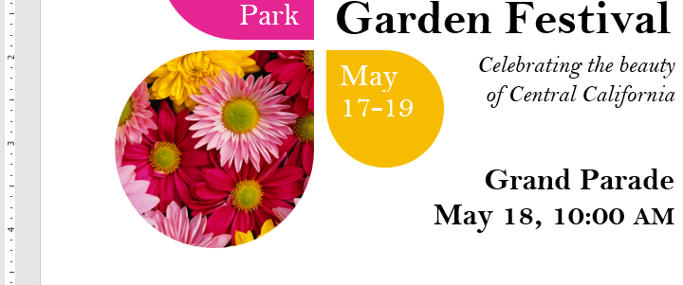

#### To add a border to a picture:

1. Select the picture you want to add a border to, then click the **Format** tab.
2. Click the **Picture Border** command. A drop-down menu will appear.
3. From here, you can select a **color**, **weight** (thickness), and whether the line is **dashed**.

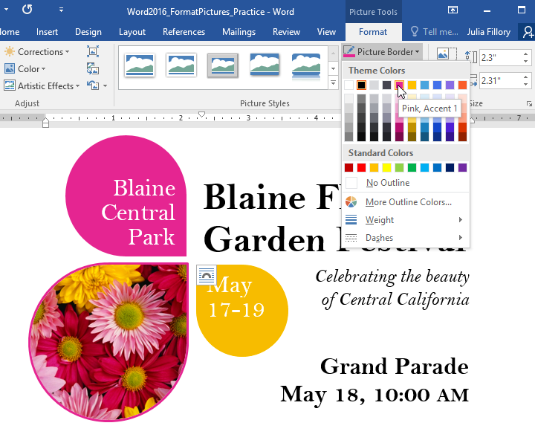

1. The border will appear around the image.

### Making image adjustments

With Word's **image adjustment tools**, you can easily fine tune properties like color, contrast, saturation, and tone. Word also offers built-in **picture styles**, which can be used to add a frame, drop shadow, and other predefined effects.

When you're ready to adjust an image, simply select it. Then use the options below, which can be found on the **Format** tab.

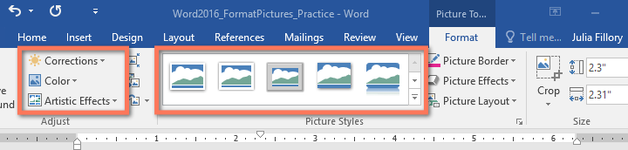

#### Corrections

From here, you can **sharpen or soften** the image to adjust how clear or blurry it appears. You can also adjust **brightness and contrast**, which affect the image's lightness and general intensity.

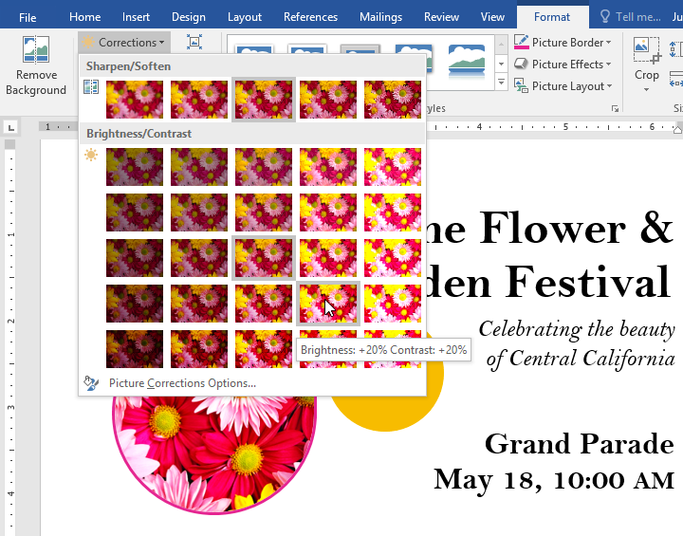

#### Color

Using this command, you can adjust the image's **saturation**(how vibrant the colors appear), **tone**(the color temperature of the image, from cool to warm), and **coloring**(the overall tint of the image).

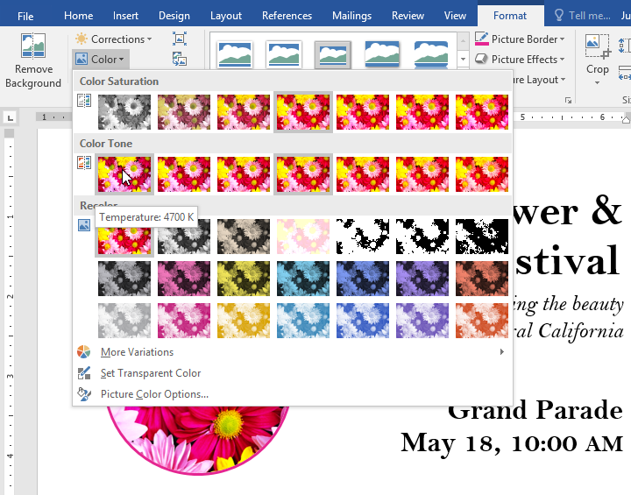

#### Artistic Effects

Here, you can apply **special effects** to your image, such as pastel, watercolor, or glowing edges. Because the results are so bold, you may want to use these effects sparingly (especially in professional documents).

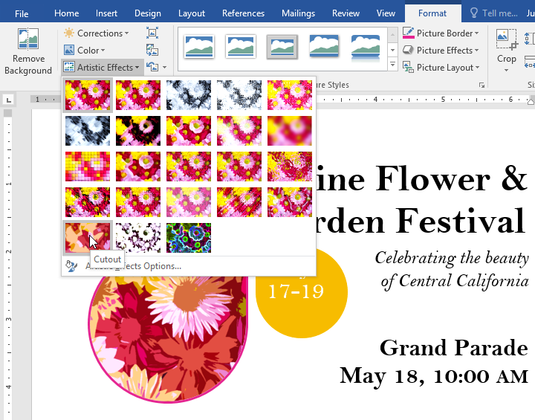

#### Picture Styles group

This group contains many different **predefined styles** that make image formatting even easier. Picture styles are designed to **frame** your image without changing its basic settings or effects.

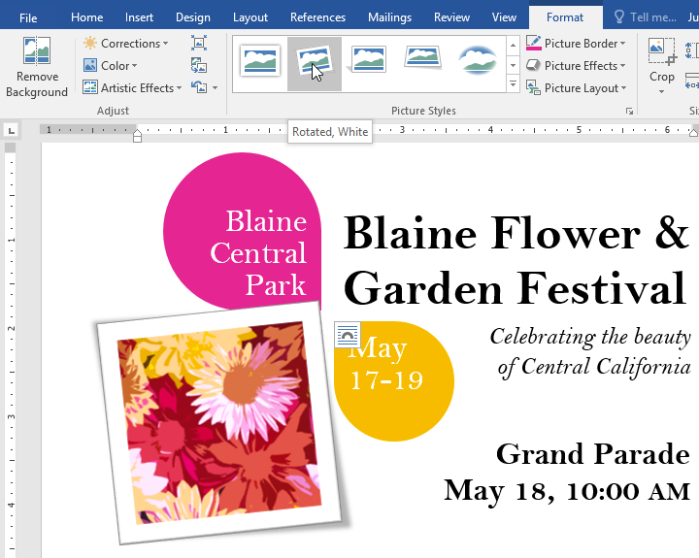

### Compressing pictures

If you plan to email a document that contains pictures, you'll need to monitor its **file size**. Large, high-resolution images can cause your document to become very large, which may make it difficult to attach to an email. Additionally, **cropped areas** of pictures are saved within the document by default, which can add to the file size.

Thankfully, you can reduce your document's file size by **compressing** your pictures. This will lower their **resolution** and **delete cropped areas**.

Compressing a picture may noticeably affect its quality (for instance, the image may become blurry or pixelated). Therefore, we recommend **saving an extra copy of your document** before you compress pictures. Alternatively, be prepared to use the **Undo command**if you're dissatisfied with the results.

#### To compress a picture:

1. Select the picture you want to compress, then navigate to the **Format** tab.
2. Click the **Compress Pictures** command.

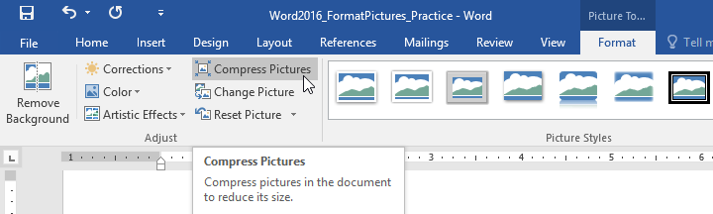

1. A dialog box will appear. Check the box next to **Delete cropped areas of pictures**. You can also choose whether to apply the settings to **this picture only** or to all pictures in the document.
2. Choose a **Target output**. If you are emailing your document, you may want to select **Email**, which produces the smallest file size.
3. Click **OK**.

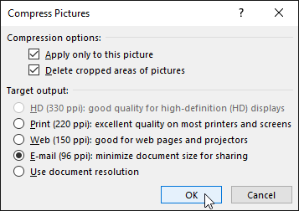

## Text Boxes

#### To insert a text box:

1. Select the **Insert** tab, then click the **Text Box** command in the **Text** group.

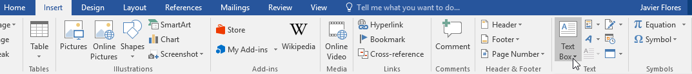

1. A drop-down menu will appear. Select **Draw Text Box**.

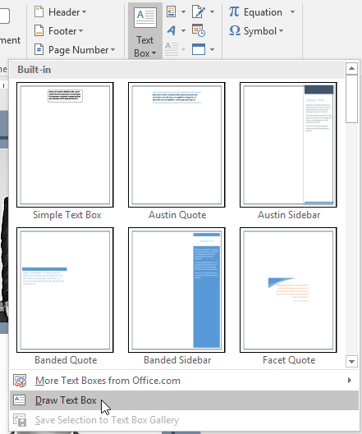

1. Click and drag anywhere on the document to create the text box.

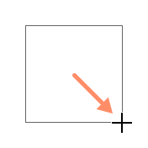

1. The insertion point will appear inside the text box. You can now type to create text inside the text box.

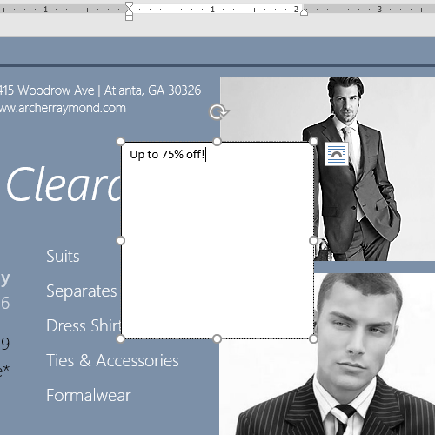

1. If you want, you can select the text and then change the **font**, **color**, and **size**by using the commands on the **Format** and **Home** tabs. To learn more about using these formatting commands, see our [**Formatting Text**](http://www.gcflearnfree.org/word2016/formatting-text/1/) lesson.



1. Click anywhere outside the text box to return to your document.

You can also select one of the **built-in** text boxes that have predefined colors, fonts, positions, and sizes. If you choose this option, the text box will appear automatically, so you will not need to draw it.

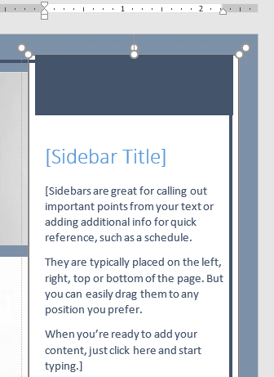

## Tables

#### To insert a blank table:

1. Place the insertion point where you want the table to appear.
2. Navigate to the **Insert** tab, then click the **Table** command.

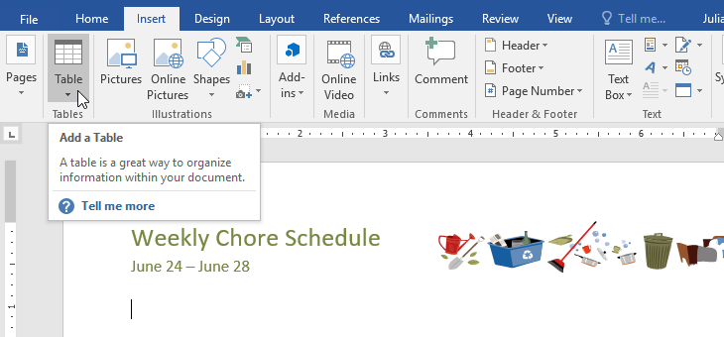

1. This will open a drop-down menu that contains a grid. Hover over the grid to select the number of **columns and rows** you want.

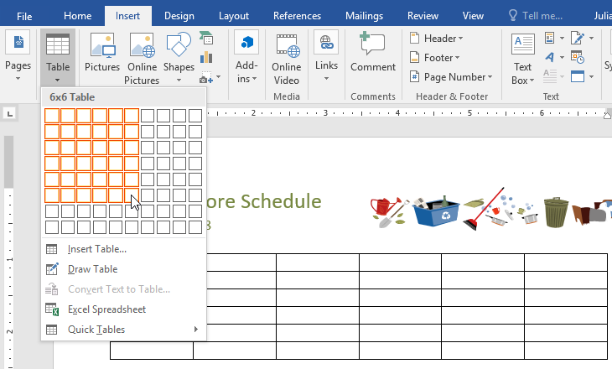

1. Click the grid to **confirm** your selection, and a table will appear.
2. To **enter text**, place the insertion point in any cell, then begin typing.

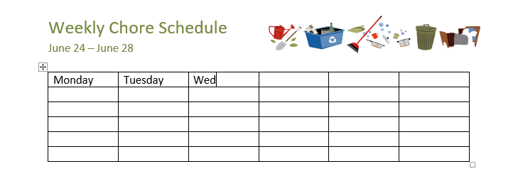

To navigate between cells, use the **Tab** key or **arrow** keys on your keyboard. If the insertion point is in the last cell, pressing the **Tab** key will automatically create a new row.

#### To convert existing text to a table:

In the example below, each line of text contains part of a **checklist**, including chores and days of the week. The items are separated by **tabs**. Word can convert this information into a table, using the tabs to separate the data into columns.

1. Select the text you want to **convert** to a table. If you're using our practice file, you can find this text on page 2 of the document.

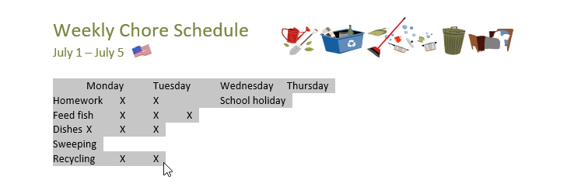

1. Go to the **Insert** tab, then click the **Table** command.
2. Select **Convert Text to Table** from the drop-down menu.

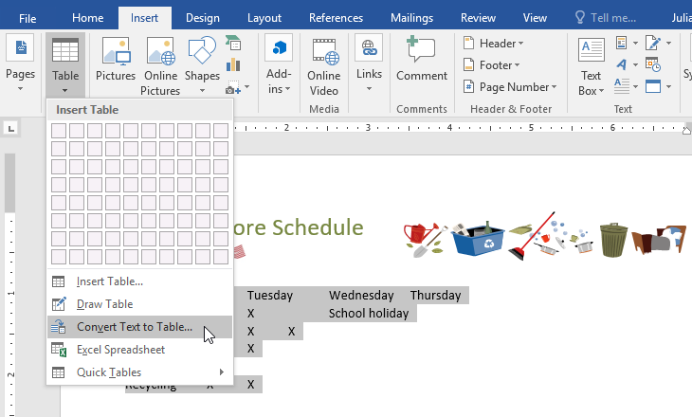

1. A dialog box will appear. Choose one of the options under **Separate text at**. This is how Word knows what to put into each column.

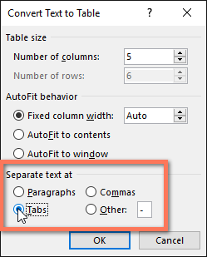

1. Click **OK**. The text will appear in a table.

## Charts

### Introduction

A **chart** is a tool you can use to **communicate information graphically**. Including a chart in your document can help you illustrate numerical data—such as comparisons and trends—so it's easier for the reader to understand

### Inserting charts

Word utilizes a separate **spreadsheet window** for entering and editing chart data, much like a spreadsheet in Excel. The process of entering data is fairly simple, but if you're unfamiliar with Excel, you might want to review our [**Cell Basics**](http://www.gcflearnfree.org/excel2016/cell-basics/1/) lesson.

#### To insert a chart:

1. Place the **insertion point** where you want the chart to appear.
2. Navigate to the **Insert** tab, then click the **Chart** command in the **Illustrations**group.

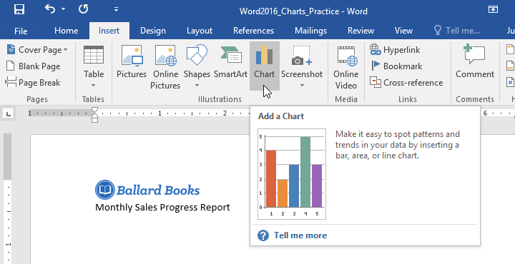

1. A dialog box will appear. To view your options, choose a **chart type** from the left pane, then browse the **charts** on the right.
2. Select the desired **chart**, then click **OK**.

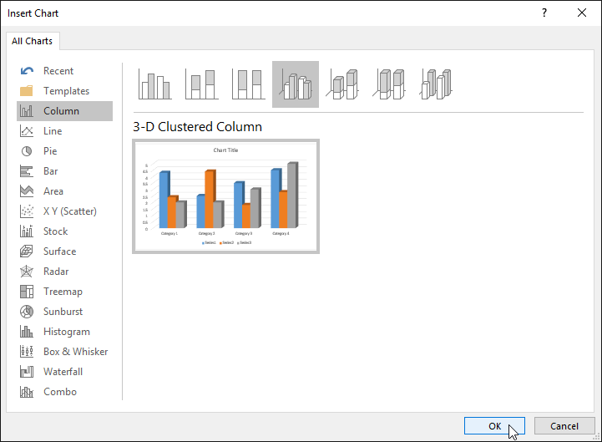

1. A chart and spreadsheet window will appear. The text in the spreadsheet is merely a **placeholder** that you'll need to replace with your own source data. The source data is what Word will use to create the chart.

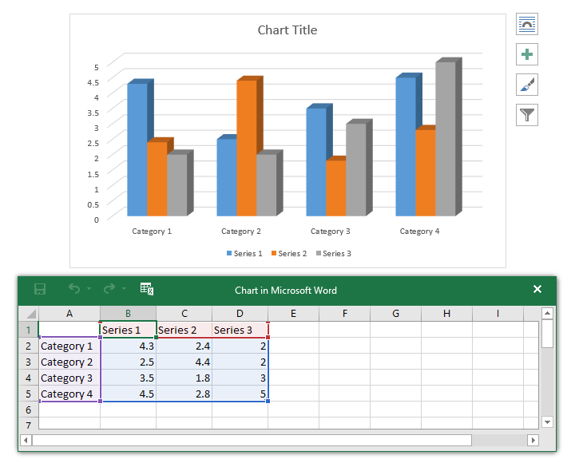

1. Enter your **source data** into the spreadsheet.

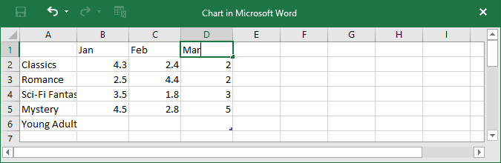

1. Only the data enclosed in the **blue box** will appear in the chart. If necessary, click and drag the **lower-right corner** of the blue box to manually increase or decrease the data range.

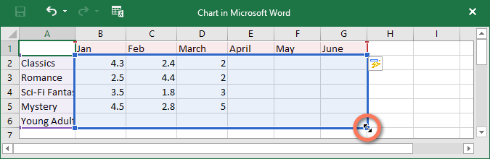

1. When you're done, click **X** to close the spreadsheet window.

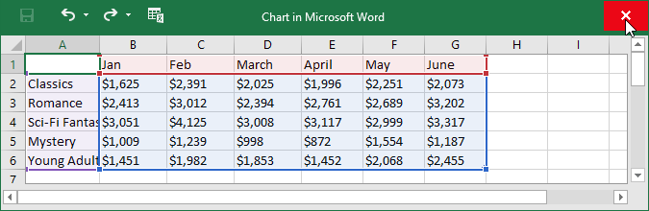

1. The chart will be complete.

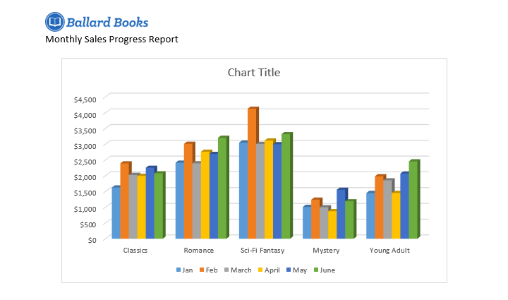

To edit your chart again, simply select it, then click the **Edit Data** command on the **Design** tab. The spreadsheet window will reappear.

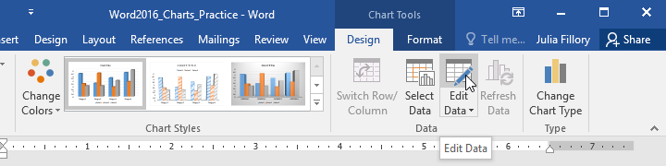

## Track Changes and Comments

#### Understanding Track Changes

When you turn on **Track Changes**, every change you make to the document will appear as a colored **markup**. If you delete text, it won't disappear—instead, the text will be **crossed** **out**. If you add text, it will be **underlined**. This allows you to see edits before making the changes permanent.

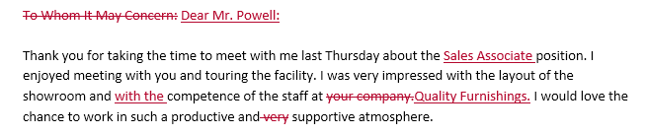

If there are multiple reviewers, each person will be assigned a different markup color.

#### To turn on Track Changes:

1. From the **Review** tab, click the **Track Changes** command.

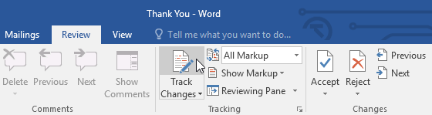

1. Track Changes will be turned on. From this point on, any changes you make to the document will appear as colored markups.

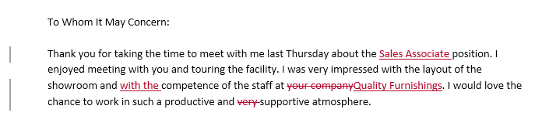

### Reviewing changes

Tracked changes are really just suggested changes. To become permanent, they must be **accepted**. On the other hand, the original author may disagree with some of the tracked changes and choose to **reject** them.

#### To accept or reject changes:

1. Select the change you want to accept or reject.

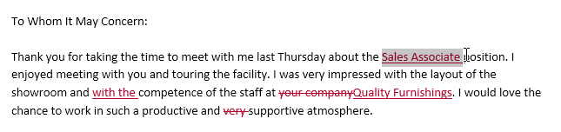

1. From the **Review** tab, click the **Accept** or **Reject** command.

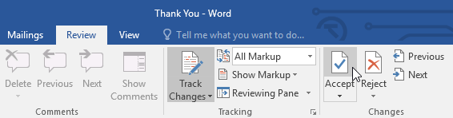

1. The markup will disappear, and Word will automatically jump to the next change. You can continue accepting or rejecting each change until you have reviewed all of them.

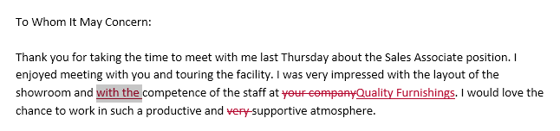

1. When you're finished, click the **Track Changes** command to **turn** **off** Track Changes.

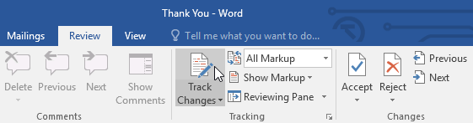

To accept all changes at once, click the **Accept** drop-down arrow, then select **Accept** **All**. If you no longer want to track your changes, you can select **Accept All and Stop Tracking**.

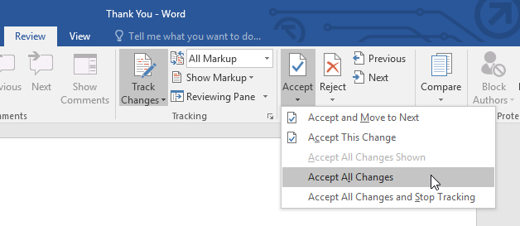

## Inspecting and Protecting Documents

### Document Inspector

Whenever you create or edit a document, certain **personal information** may be added to the file automatically—for example, information about the document's author. You can use **Document Inspector** to remove this type of information before sharing a document with others.

Because some changes may be permanent, it's a good idea to use **Save As** to create a backup copy of your document before using Document Inspector.

#### To use Document Inspector:

1. Click the **File** tab to go to **Backstage view**.
2. From the **Info** pane, click **Check for Issues**, then select **Inspect** **Document** from the drop-down menu.

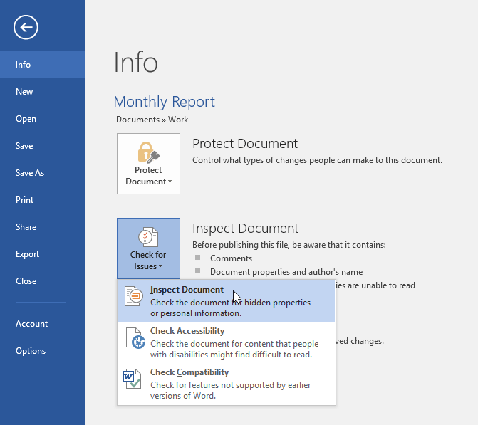

1. **Document Inspector**will appear. Check or uncheck the boxes, depending on the content you want to review, then click **Inspect**. In our example, we'll leave everything selected.

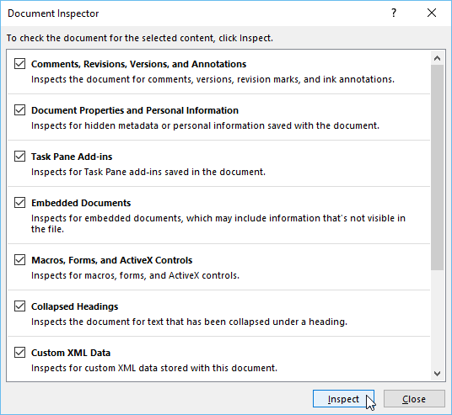

1. The inspection results will show an **exclamation mark** for any categories where it found potentially sensitive data, and it will also have a **Remove All** button for each of these categories. Click **Remove All** to remove the data.

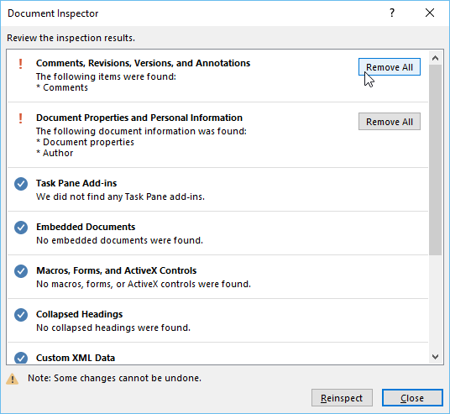

1. When you're done, click **Close**.

### Protecting your document

By default, anyone with access to your document will be able to open, copy, and edit its content unless you **protect** it. There are several ways to protect a document, depending on your needs.

#### To protect your document:

1. Click the **File** tab to go to **Backstage view**.
2. From the **Info** pane, click the **Protect Document**command.
3. In the drop-down menu, choose the option that best suits your needs. In our example, we'll select **Mark** **as Final**. Marking your document as final is a good way to discourage others from editing the file, while other options give you more control if you need it.

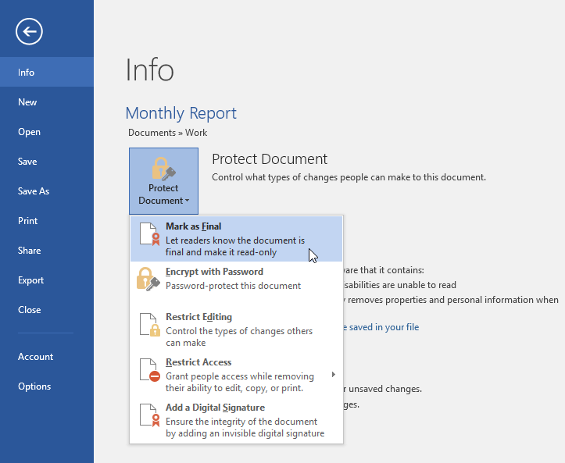

1. A dialog box will appear prompting you to save. Click **OK**.

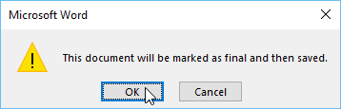

1. Another dialog box will appear. Click **OK**.

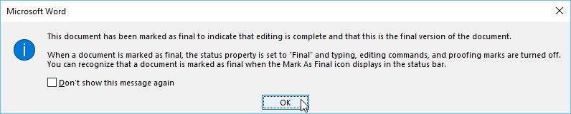

1. The document will be **marked as final**. Whenever others open the file, a bar will appear at the top to discourage them from editing the document.

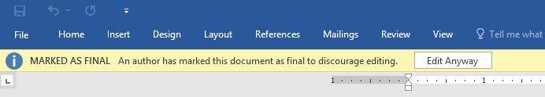

Marking a document as final will not actually prevent others from editing it because they can just select **Edit Anyway**. If you want to prevent people from editing the document, you can use the **Restrict Access** option instead.

**Table of Contents**

Users can automatically generate a table of contents for their document provided they created the headings and subheadings as we explained in Topic 2C on p. 5.

On a blank page after your cover where you want a Table of Contents, just click on Table of Contents icon and you will open a dialog where you can then click on the desired TOC format.

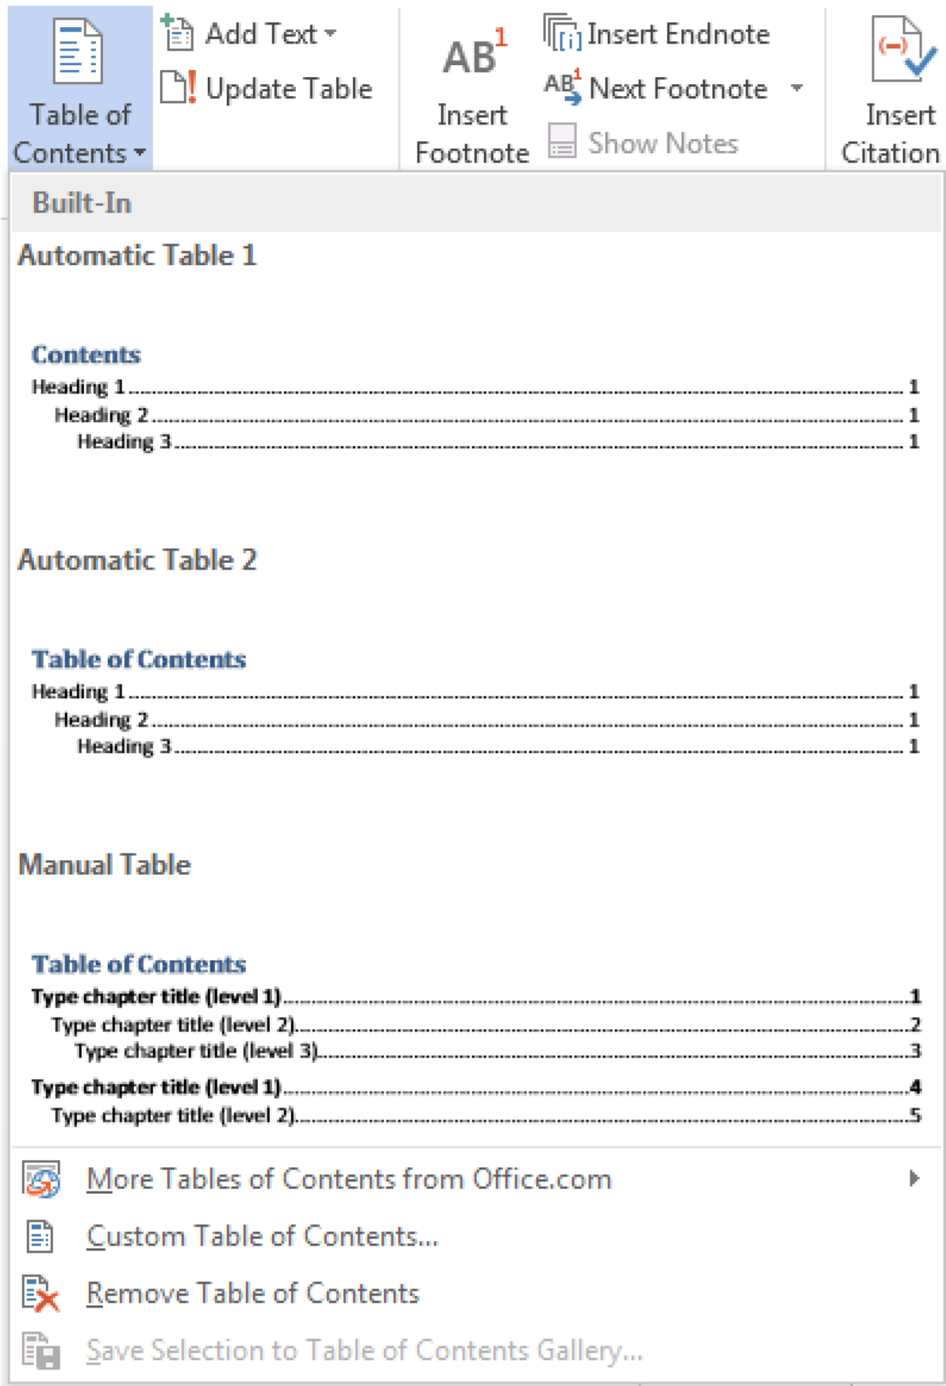

B. Footnotes

Footnotes are an important part of any research paper. These citations can be added to the bottom of the page or as endnotes. If you click the little arrow at the bottom left of the footnote section of the References ribbon, you will open a dialog.

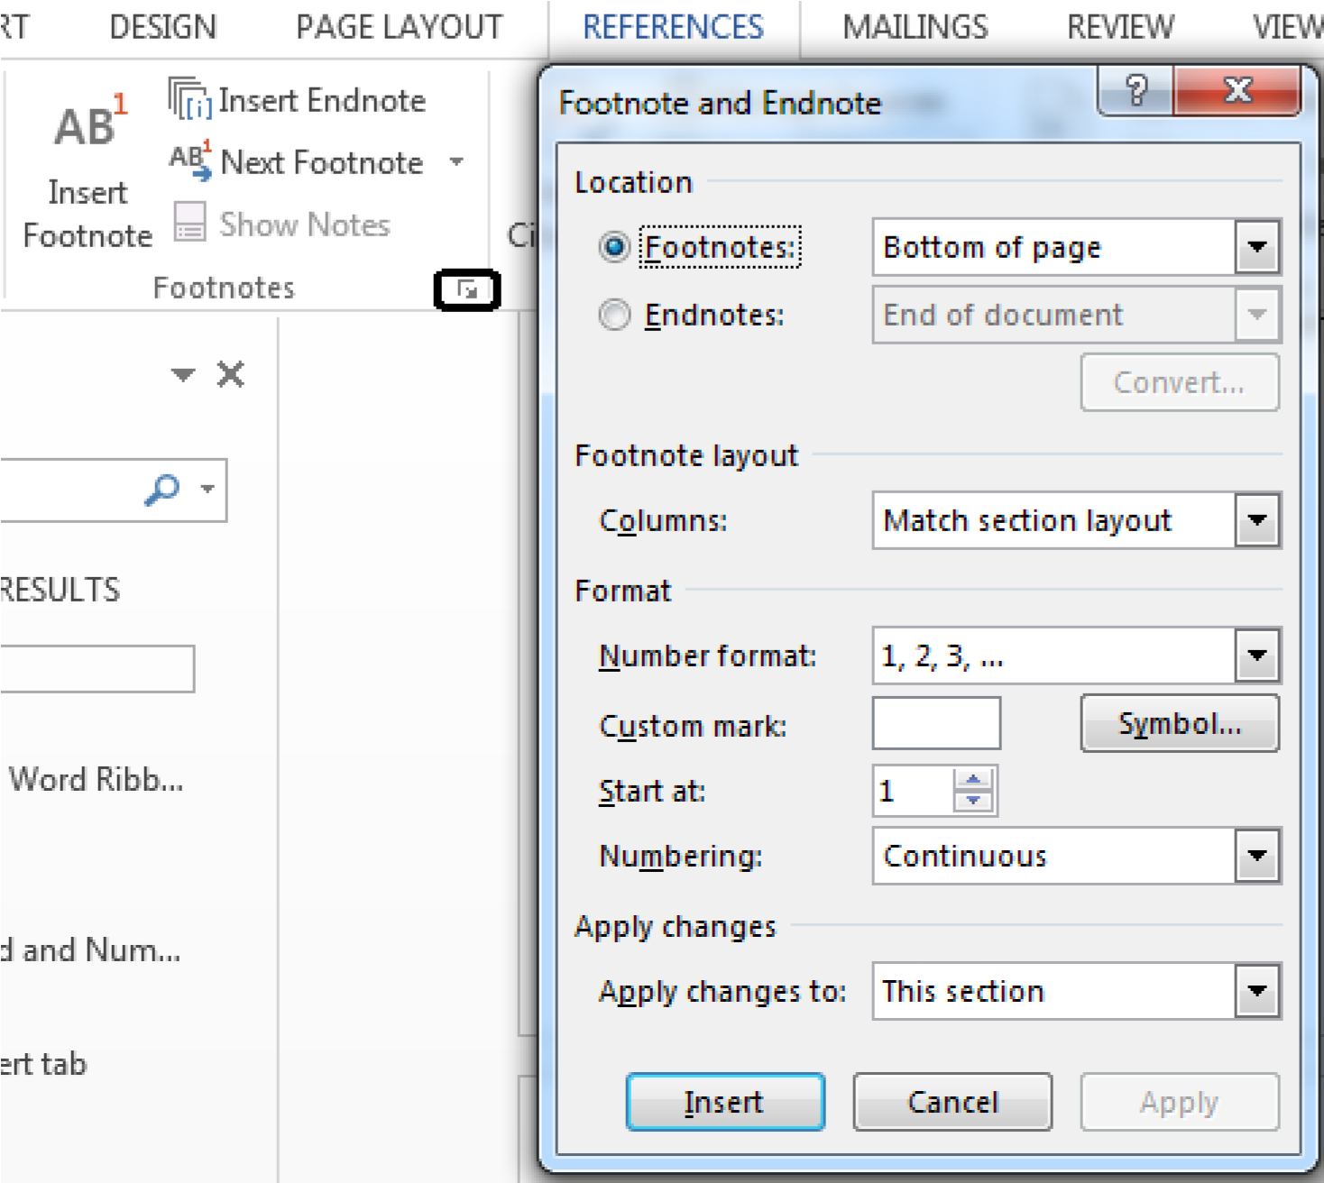

C. Citations and Bibliography

MS Word 2013 has added icons for inserting citations and managing resources within the document.

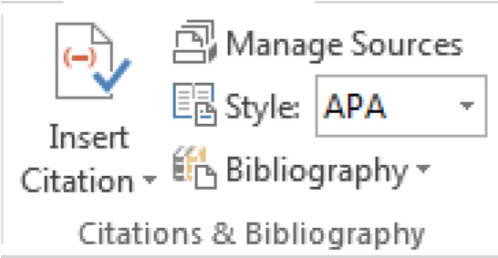

D. Captions

Captions have been added to the References ribbon to allow you the ability to insert table of figures and cross reference as well as inserting a caption.

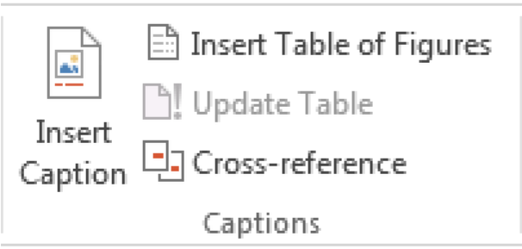

Task#01

Write a letter to your father requesting him to send 40,000/- for the purchase of software Insert a table containing specification and size of the software. Save and print also.

Task#02

Write an invitation to your friend invite him/her to your birthday party. Give a page border to your invitation insert graphic from event category. Set landscape as orientation.

Task#03

Using MS-WORD create a flyer of A4 size paper /letter. Use complete drawing Menu, Fonts and Borders.

Task#04

Create curriculum vitae.

1. Personal using tab keys and format tool

2. Academic qualification using tables

3. Working experiences using table

4. Hobbies using simple format